**GUIDE TO VIEW STATUS OF YOUR WORKDAY PROCESS DRAFT 1/15/2025**

1. Select your Task Inbox in the top right corner of your Workday home dashboard

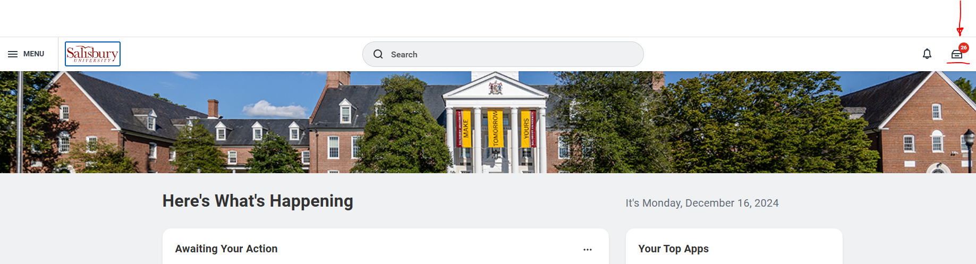

1. Select your task Archive, and search the Archive for the individual in question. You can also use “Advanced Search” to filter by task type and date ranges:

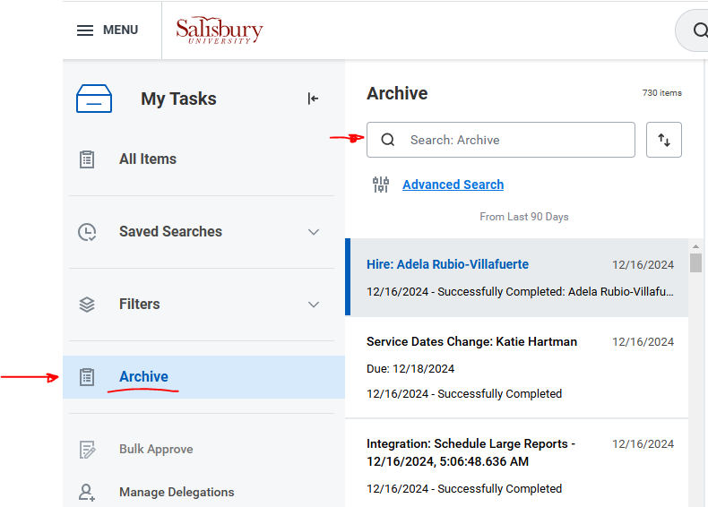

1. Select the initial task for your submission (i.e, “Hire”). In the View Event window on the right, select the “Process” tab and scroll to the bottom to see what step is awaiting action in the hire process. You may need to move to the next page of the process to see the current step:

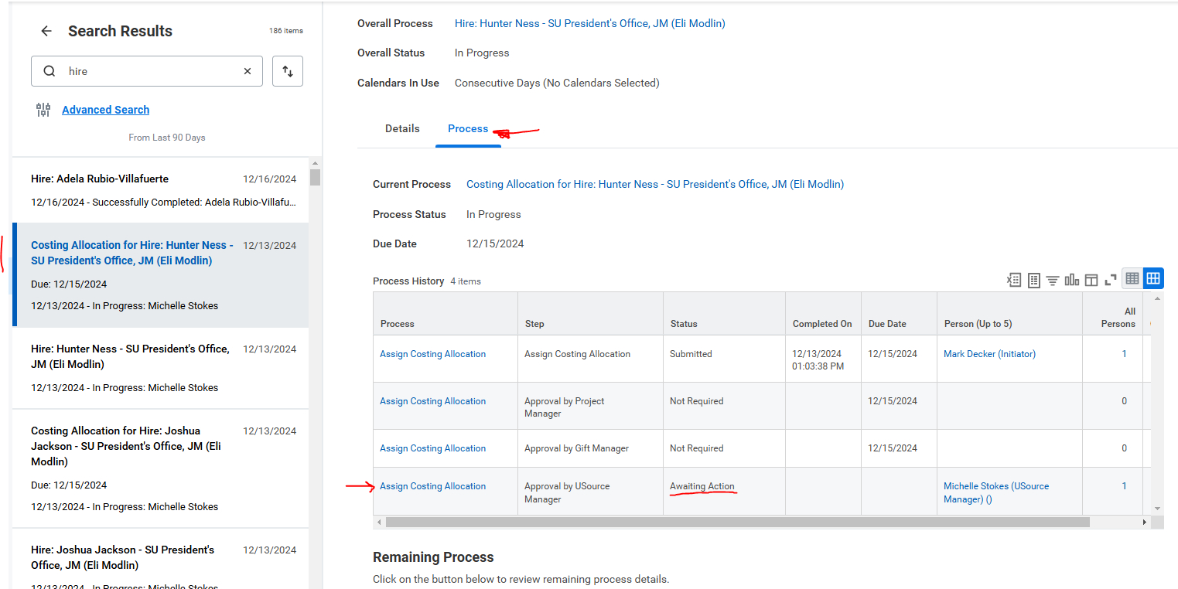

**HOW TO CANCEL A PENDING SUBMISSION:**

You must be in the **Overall Process** (in the screenshot above, the blue text link to the right of “**Overall Process**”. Once you are in the View Event screen, you can select the three dot icon (the “twinkie”) to the right of the process, navigate to “Business Process” and then select “Cancel.” (NOTE: The “twinkie” will appear when you hover your cursor over the process name)

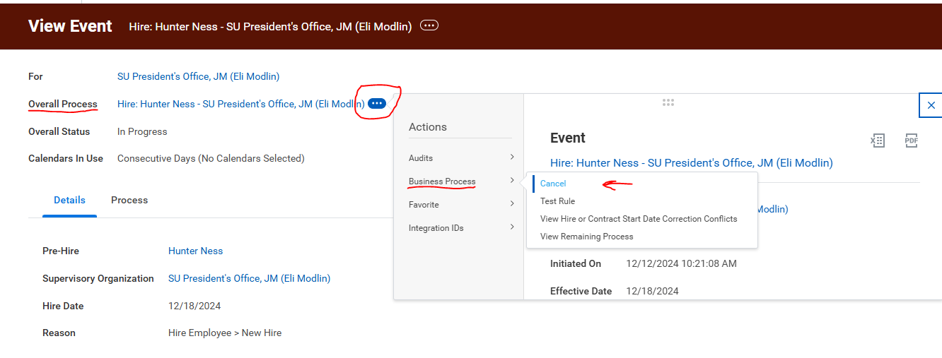

Be advised that once the contract proceeds past the Generate Document step (the HCMAI submits the actual contract document to be signed), the process can no longer be canceled, as the contract is considered completed. You will need to submit a Workday ticket to request the contract be rescinded.