

SALISBURY UNIVERSITY

Closing the Achievement Gap Institutional
2015 Report

February 2015
- Defining Salisbury University’s Achievement Gap

The Achievement Gap at Salisbury University (SU) is defined by the following goals:
- Improve second-year retention rates for Hispanic and African American students; and
- Continue to monitor and make progress toward improving six-year graduation rates of Hispanic, African American, low-income, and all SU students.

- Achievement Gap Plan

The table below demonstrates that gaps for low-income students have closed dramatically since implementation in academic year 2008-09. The six-year graduation rate gap for low-income students has closed 7 percentage points, from a 15 percentage point gap (2002 cohort) to an eight percentage point gap (2008 cohort).

When comparing the six-year graduation rate gap between African American students and the overall population at SU, the most recent data (2008 cohort) indicates a 13 percentage point gap between these cohorts at SU. The 2002 cohort was used to identify an original graduation rate gap of 12 percentage points between African American and overall student groups. While the 2005 and 2006 cohorts of African American students demonstrated substantial progress toward closing the graduation rate gap, the rates of the 2007 and 2008 cohorts did not demonstrate further progress toward closing the gap. An examination of yearly retention rates for the 2008 cohort revealed that their retention rates dipped early on for the cohort. Efforts to close the achievement gap were piloted in fall 2008 and fully implemented in fall 2009. Retention and early graduation rates (four- and five-year) for subsequent African American cohorts appear to be more positive. Second-year retention rates for the 2009 cohort of African American students, the first cohort following full implementation of achievement gap retention initiatives, are seven percentage points higher than the 2002 baseline cohort.

While additional efforts continue to be made to close the gap for our Hispanic cohort, the large year-to-year variability in the rates for this group is likely due to its very small sample size. As the Hispanic cohort continues to grow, this rate will become more stable. The six-year graduation rate gap between the 2008 cohort of Hispanic students and overall rates decreased 11 percentage points this year. However, there is still an 11 percentage point gap between Hispanic students and the overall population of SU students, 55% vs 66%, respectively. With a mere 40 Hispanic students in the cohort, the impact of any one student on retention and graduation rates is inflated. The graduation of five more Hispanic students from the 2008 cohort would have decreased the gap to 0%. Similar to the early results for the 2009 and 2010 cohorts of African American students, retention rates for Hispanic students also to show positive gains in retaining these students at SU.
- Graph Showing Trend Data for Gap
Table 1: Graduation and Retention Rate Trends
Salisbury University | Six-year Graduation and Retention Rates at Institutions of First-Entry
 | Fall Cohort First-Time Full Time | 2002 | 2003 | 2004 | 2005 | 2006 | 2007 | 2008 | 2009 | 2010 | 2011 | 2012 | 2013
 | FY Graduation Year | 2008 | 2009 | 2010 | 2011 | 2012 | 2013 | 2014 | 2015 | 2016 | 2017 | 2018 | 2019
Salisbury University  Total | 6-Year Graduation Rate | 69% | 66% | 70% | 67% | 67% | 67% | 66%
Salisbury University  Total | 2nd Year Retention | 80% | 83% | 83% | 81% | 81% | 83% | 80% | 81% | 83% | 84% | 81% | 82%
Salisbury University  Total | 3rd Year Retention | 73% | 75% | 74% | 73% | 74% | 73% | 73% | 73% | 74% | 76% | 74%
Salisbury University  Total | 4th Year Retention | 71% | 70% | 70% | 69% | 70% | 69% | 69% | 69% | 72% | 72%
Salisbury University  Total | 5th Year Retention | 23% | 23% | 24% | 22% | 20% | 21% | 22% | 20% | 21%
Salisbury University  Total | Graduated in 5 Years or Less | 65% | 63% | 66% | 63% | 64% | 64% | 63% | 65% | 47%*
Salisbury University  Total | Cohort Size | 899 | 947 | 981 | 952 | 1028 | 1142 | 1198 | 1272 | 1247 | 1246 | 1230 | 1241
Salisbury University  African American | 6-Year Graduation Rate | 57% | 62% | 53% | 60% | 66% | 54% | 53%
Salisbury University  African American | The Gap | -12 | -4 | -17 | -7 | -1 | -13 | -13
Salisbury University  African American | 2nd Year Retention | 75% | 83% | 80% | 83% | 86% | 76% | 78% | 82% | 84% | 81% | 83% | 84%
Salisbury University  African American | 3rd Year Retention | 74% | 75% | 65% | 66% | 77% | 64% | 64% | 69% | 73% | 70% | 74%
Salisbury University  African American | 4th Year Retention | 64% | 73% | 57% | 66% | 74% | 62% | 60% | 65% | 74% | 68%
Salisbury University  African American | 5th Year Retention | 37% | 39% | 31% | 35% | 34% | 23% | 23% | 24% | 33%
Salisbury University  African American | Graduated in 5 Years or Less | 45% | 57% | 47% | 51% | 57% | 49% | 47% | 59% | 34%*
Salisbury University  African American | Cohort Size | 84 | 79 | 75 | 94 | 125 | 129 | 115 | 131 | 128 | 91 | 107 | 97
Salisbury University  Hispanic | 6-Year Graduation Rate | 74% | 64% | 70% | 60% | 43% | 45% | 55%
Salisbury University  Hispanic | The Gap | +5 | -2 | 0 | -7 | -24 | -22 | -11
Salisbury University  Hispanic | 2nd Year Retention | 83% | 82% | 91% | 80% | 63% | 72% | 70% | 80% | 90% | 85% | 75% | 71%
Salisbury University  Hispanic | 3rd Year Retention | 75% | 82% | 74% | 72% | 50% | 62% | 68% | 65% | 72% | 67% | 68%
Salisbury University  Hispanic | 4th Year Retention | 75% | 67% | 78% | 68% | 50% | 55% | 60% | 65% | 79% | 67%
Salisbury University  Hispanic | 5th Year Retention | 46% | 18% | 30% | 36% | 17% | 21% | 25% | 27% | 26%
Salisbury University  Hispanic | Graduated in 5 Years or Less | 61% | 64% | 57% | 60% | 40% | 41% | 55% | 55% | 49%*
Salisbury University  Hispanic | Cohort Size | 24 | 33 | 23 | 25 | 30 | 29 | 40 | 55 | 72 | 73 | 65 | 62
Salisbury University Low- Income (Pell) | 6-Year Graduation Rate | 54% | 59% | 63% | 62% | 62% | 64% | 58%
Salisbury University Low- Income (Pell) | The Gap | -15 | -7 | -7 | -5 | -5 | -3 | -8
Salisbury University Low- Income (Pell) | 2nd Year Retention | 71% | 81% | 79% | 85% | 78% | 82% | 78% | 81% | 79% | 77% | 79% | 82%
Salisbury University Low- Income (Pell) | 3rd Year Retention | NOT | 69% | 71% | 70% | 70% | 71% | 67% | 74% | 71% | 69% | 70%
Salisbury University Low- Income (Pell) | 4th Year Retention |  | 63% | 65% | 67% | 67% | 65% | 64% | 69% | 67% | 67%
Salisbury University Low- Income (Pell) | 5th Year Retention | AVAILABLE | 33% | 33% | 30% | 24% | 24% | 24% | 28% | 26%
Salisbury University Low- Income (Pell) | Graduated in 5 Years or Less |  | 54% | 56% | 58% | 56% | 61% | 54% | 62% | 35%*
Salisbury University Low- Income (Pell) | Cohort Size | 134 | 129 | 110 | 112 | 126 | 152 | 140 | 220 | 263 | 229 | 202 | 221
*For the 2010 cohort, the graduation rates reported represent the 4-year graduation rate as of spring 2014.

- Summary of FY13 Initiatives and Participant Data

SU utilizes a number of initiatives to help narrow the achievement gap. These initiatives include:
- Mid-semester reporting and advising
All first-year students receiving grades of “D” or “F” at mid-semester are contacted and provided with additional advising, mentoring, and tutoring assistance.
- Living learning communities
Living learning communities (LLCs) are specialized living options offered to first-year students. They provide students with the opportunity to live with other first-year students with similar interests. Students that participate in LLCs are enrolled in common courses with other students living on their residence hall floor and participate in outside-of-class activities with each other.
- Supplemental instruction
Supplemental Instruction (SI) is a peer tutoring program designed to organize and improve students’ outside-of-class course preparation. SI is offered for traditionally challenging courses. An SI leader, a student who has demonstrated proficiency in a targeted course and undergoes SI training, is assigned to each course. SI leaders attend the class and conduct study sessions for students three times a week.
- Student Support Services (SSS) TRiO Program
The ACHIEVE SSS Project offers interventions that bridge the gap in completion by helping SSS-eligible students (i.e., low-income, first generation or students with a disability) overcome both academic and personal barriers to graduation. The project provides a summer bridge program, academic success workshops, individual academic, personal and career counseling, financial literacy education, mentoring relationships, and supplemental grants.

- Assessment of Each Initiative

Mid-Semester Reporting
All first-time, first-year students with a faculty reported “D” or “F” at mid-semester are contacted by the Center for Student Achievement (CSA) in an attempt to offer some form of academic support or advising. During the 2013-14 academic year, 186 first-time, first-year students were identified as having a “D” or “F” in at least one course at mid-semester. This represents approximately 15% of the 2013 incoming student cohort. Nearly 21% of first-time, first-year minority students were identified as having a “D” or “F” at mid-semester. Of the 186 first-time students receiving a mid-semester “D” or “F,” 67 (36%), attended the CSA for remediation.

Students that attended the CSA for academic support had higher grades at the end of their first year (2.50) than those that had a “D” or “F” at mid-semester but did not attend the CSA (2.44). Additionally, students that attended the CSA following poor mid-semester performance were retained into their second year at higher rates (79%) than students that did not seek out assistance at the CSA (69%). The positive results have led to an expansion of tutors at the CSA and the opening of two additional CSA sites on campus. The initiative appears to be successful and proving to be more effective each year. With the expansion of CSA, more students are aware of the services that the center offers and are seeking out academic assistance when it is needed.

Living Learning Communities
Approximately 328 freshmen, 26% of the first-time student cohort, participated in an LLC during academic year 2013-14. In addition, 32% of first-time minority students participated in one of the identified LLCs during 2013-14.

Students enrolled in an LLC had higher first-year grades than those that were not in an LLC during their first year at SU (3.16 vs. 2.98). The data also showed that LLC participants were retained into their second year at higher rates than non-LLC participants (87% vs. 81%).

With five consecutive years of positive results, participation and the number of LLCs available to students continue to grow. For fall 2014, 19 LLCs were available to students. LLC offerings included: Art, Music, Theatre, Wellness, Nursing, Biology, STEM, Global Village, Elementary Education, Secondary Education, Human Services, Honors (3), Business (3), Green, and Gender Studies.

Supplemental Instruction
Some 856 freshmen, 69% of the first-time student cohort, participated in SI during the 2013-2014 academic year. Due to the expansion in the number of course sections served by SI tutors/instructors, the program served an additional 17% of the first-time student cohort compared to 2012-13. Approximately 68% of first-time minority students participated in a SI course during 2013-2014. To determine the impact of the SI program, SI participants that attended at least five of the outside-of-class SI sessions were compared to students that attended fewer than five sessions. Of the 856 first-time students that participated in SI, 330 (39%) attended at least five SI sessions.

Students who attended five or more SI sessions had higher first-year grades than students who attended less than five SI sessions (3.20 vs. 2.88). SI students who attended five or more sessions had higher second-year retention rates than those who attended less than five sessions and the overall population of first-time students (89% vs. 81% vs. 82%).

Based on positive results for the previous four academic years, SI was expanded from 16 to more than 131 SI sections during academic year 2013-14. During academic year 2014-15, over 150 sections of SI will be offered. Since its implementation in 2009, the program has grown to include more than six times the original number of SI sections and to include courses across each of the four endowed schools.

Summary of All Initiatives
Overall, the impact of the three initiatives implemented to close the achievement gap has been positive. With respect to student grades and retention rates, Supplemental Instruction and LLCs have had the greatest impact on improving first-year student performance and success.

Chart 1: Average GPA for Participants in the Closing the Achievement Gap Initiatives
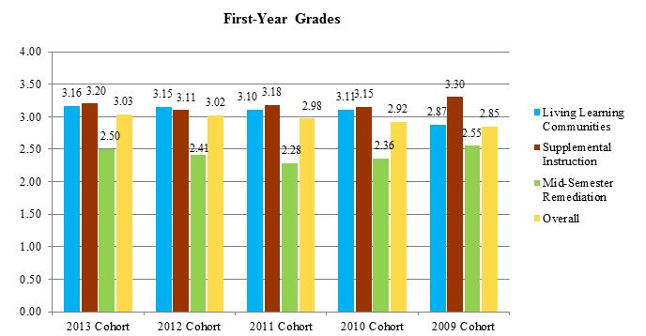

Chart 2: Retention Rates for Participants in the Closing the Achievement Gap Initiatives
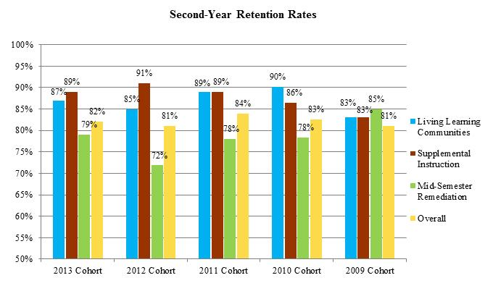
- Trajectory Demonstrating Intermediate Achievement Gap Goals

The following charts demonstrate the expected changes in six-year graduation rates for African American, low-income, and Hispanic students. The trajectories are based on closing the achievement gap between these subgroups and the University’s overall six-year graduation rates. Goals are set to cut the gap in half by 2015 (2009 cohort) and eliminate it by 2020 (2014 cohort). Based on the successful implementation and funding of the initiatives, a six-year graduation trajectory was projected during AY 2010-11. Actual six-year graduation rates are charted against this projection to determine our progress towards closing the achievement gap.

Chart 3: African American Student 6-Year Graduation Rate Trajectory
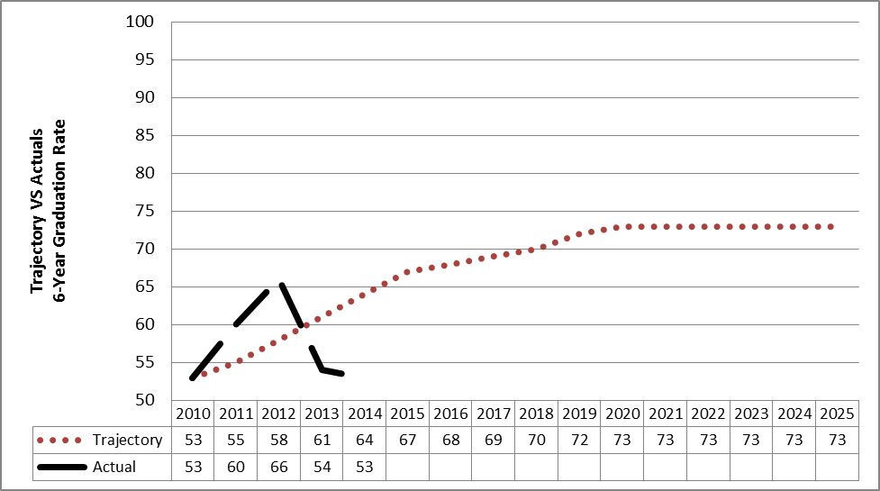
*Note. The trajectory is based on closing a 12 percentage point gap (2002 cohort) between African American and overall six-year graduation rates.
Chart 4: Low-Income (Pell Eligible) Student 6-Year Graduation Rate Trajectory
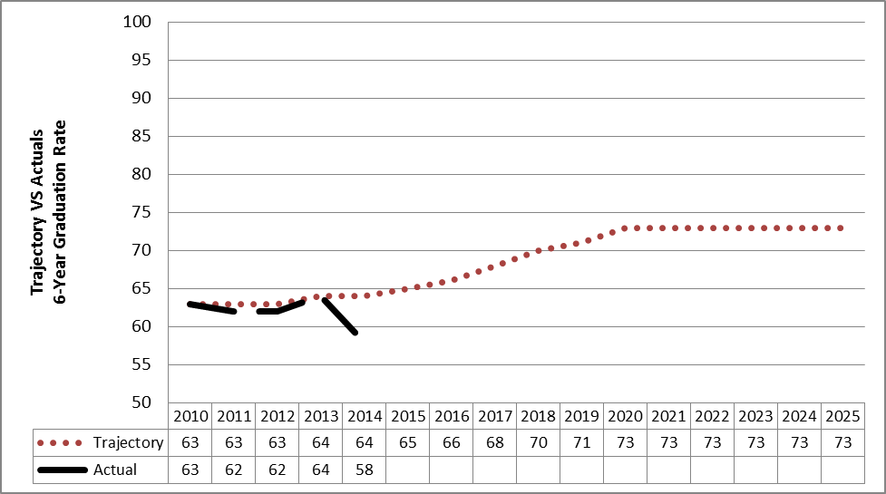
*Note. The trajectory is based on closing a 15 percentage point gap (2002 cohort) between low-income and overall six-year graduation rates.

Chart 5: Hispanic Student 6-Year Graduation Rate Trajectory
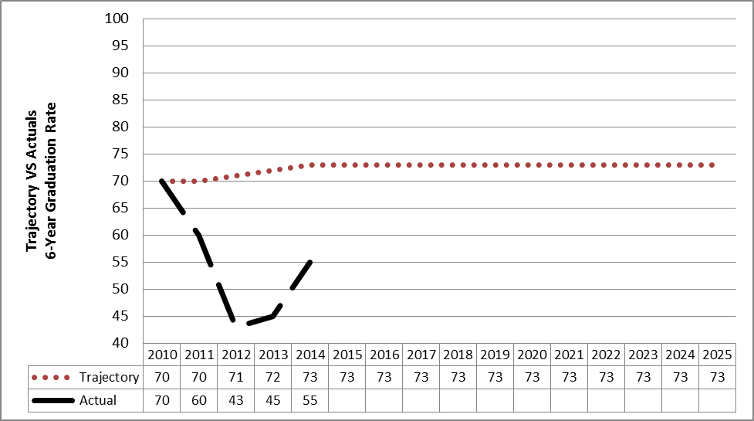
*Note. The trajectory is based maintaining the same six-year graduation rates for Hispanic and SU’s overall cohort of first-time, first-year students.

