

SALISBURY UNIVERSITY

Closing the Achievement Gap Institutional
2013 Report

March 2013
- Defining Salisbury University’s Achievement Gap
The Achievement Gap at Salisbury University (SU) is defined by the following goals:
- Improve second-year retention rates for Hispanic and African American students; and
- Continue to monitor and make progress toward improving four- and six-year graduation rates of Hispanic, African American, low-income, and all SU students.

- Achievement Gap Plan
The tables below demonstrate that gaps for low-income and African American students have closed dramatically since implementation in academic 2008-09. The six-year graduation rate gap for low-income students has closed 10 percentage points, from a 15 percentage point gap to a 5 percentage point gap. The graduation rate gap for African American students has decreased from a 12 percentage point difference to a mere one percentage point gap. However, additional efforts are being made to close a growing gap for our Hispanic cohort. The University acknowledges the gap but also notes that the large variability in the rates for this group year-to-year are likely due to its very small sample size. As the Hispanic cohort continues to grow, this rate will become more stable. Positive results can be seen with the Hispanic cohort when the four-year graduation rates are examined.
- Graph Showing Trend Data for Gap
Table 1: Six-Year Graduation Rate Trends
 | Fall 2002 | Fall 2003 | Fall 2004 | Fall 2005 | Fall 2006
 | As of Fall 2008 | As of Fall 2009 | As of Fall 2010 | As of Fall 2011 | As of Fall 2012
Low-Income
6-Yr Grad Rate | 54% | 59% | 63% | 62% | 62%
Cohort Size | 134 | 129 | 110 | 112 | 126
GAP | -15 | -7 | -7 | -5 | -5
African American
6-Yr Grad Rate | 57% | 62% | 53% | 60% | 66%
Cohort Size | 84 | 79 | 75 | 94 | 125
GAP | -12 | -4 | -17 | -7 | -1
Hispanic
6-Yr Grad Rate | 74% | 64% | 70% | 60% | 43%
Cohort Size | 23 | 33 | 23 | 25 | 30
GAP | +5 | -2 | 0 | -7 | -24
ALL SU STUDENTS
6-Yr Grad Rate | 69% | 66% | 70% | 67% | 67%
Cohort Size | 900 | 947 | 981 | 952 | 1028
*Note. Low-income cohort size is representative of full-time, first-time, degree-seeking students that received a Pell grant during their first year at SU.

Table 2: Four-Year Graduation Rate Trends
 | Fall 2002 | Fall 2003 | Fall 2004 | Fall 2005 | Fall 2006 | Fall 2007 | Fall 2008
 | As of Fall 2006 | As of Fall 2007 | As of Fall 2008 | As of Fall 2009 | As of Fall 2010 | As of Fall 2011 | As of Fall 2012
Low-Income
4-Yr Grad Rate | 30% | 32% | 32% | 38% | 40% | 38% | 36%
Cohort Size | 134 | 129 | 110 | 112 | 126 | 153 | 140
GAP | -16 | -14 | -15 | -8 | -8 | -7 | -8
African American
4-Yr Grad Rate | 19% | 27% | 24% | 26% | 33% | 28% | 31%
Cohort Size | 84 | 79 | 75 | 94 | 125 | 129 | 115
GAP | -27 | -19 | -23 | -20 | -15 | -17 | -13
Hispanic
4-Yr Grad Rate | 35% | 45% | 43% | 40% | 30% | 24% | 38%
Cohort Size | 23 | 33 | 23 | 25 | 30 | 29 | 40
GAP | -11 | -1 | -4 | -6 | -18 | -21 | -6
ALL SU STUDENTS
4-Yr Grad Rate | 46% | 46% | 47% | 46% | 48% | 45% | 44%
Cohort Size | 900 | 947 | 981 | 956 | 1028 | 1143 | 1199
*Note. Low-income cohort size is representative of full-time, first-time, degree-seeking students that received a Pell grant during their first year at SU.
Table 3: Second-Year Retention Rate Trends
 | Fall 2002 | Fall 2003 | Fall 2004 | Fall 2005 | Fall 2006 | Fall 2007 | Fall 2008 | Fall 2009 | Fall 2010 | Fall 2011
 | As of Fall 2003 | As of Fall 2004 | As of Fall 2005 | As of Fall 2006 | As of Fall 2007 | As of Fall 2008 | As of Fall 2009 | As of Fall 2010 | As of Fall 2011 | As of Fall 2012
Low-Income
2-Yr Retention Rate | 71% | 81% | 79% | 88% | 78% | 82% | 78% | 81% | 79% | 77%
Cohort Size | 134 | 129 | 110 | 112 | 126 | 153 | 140 | 220 | 263 | 229
GAP | -9 | 0 | -4 | +7 | -3 | -1 | -2 | 0 | -4 | -7
African American
2-Yr Retention Rate | 75% | 83% | 80% | 83% | 86% | 76% | 78% | 81% | 84% | 81%
Cohort Size | 84 | 79 | 75 | 94 | 125 | 129 | 115 | 132 | 128 | 91
GAP | -5 | +2 | -3 | +2 | +5 | -7 | -2 | 0 | +1 | -3
Hispanic
2-Yr Retention Rate | 83% | 82% | 91% | 80% | 63% | 72% | 70% | 80% | 90% | 85%
Cohort Size | 24 | 33 | 23 | 25 | 30 | 29 | 40 | 55 | 72 | 73
GAP | +3 | +1 | +8 | -1 | -18 | -11 | -10 | -1 | +7 | +1
ALL SU STUDENTS
2-Yr Retention Rate | 80% | 81% | 83% | 81% | 81% | 83% | 80% | 81% | 83% | 84%
Cohort Size | 900 | 947 | 981 | 956 | 1028 | 1143 | 1199 | 1275 | 1247 | 1246
*Note. Low-income cohort size is representative of full-time, first-time, degree-seeking students that received a Pell grant during their first year at SU.

- Summary of FY12 Initiatives and Participant Data
SU utilizes a number of initiatives to help narrow the achievement gap. These initiatives include the following:
- Mid-semester reporting and advising
  - All first-year students receiving grades of “D” or “F” at mid-semester are contacted and provided with additional advising, mentoring, and tutoring assistance.
- Living learning communities.
  - Living learning communities (LLCs) are specialized living options offered to first-year students. They provide students with the opportunity to live with other first-year students with similar interests. Students that participate in LLCs are enrolled in common courses with other students living on their residence hall floor and participate in outside-of-class activities with each other.
- Supplemental instruction
- Supplemental Instruction (SI) is a peer tutoring program designed to organize and improve students’ outside-of-class course preparation. SI is offered for traditionally challenging courses. An SI leader, a student who has demonstrated proficiency in a targeted course and undergoes SI training, is assigned to each course. SI leaders attend the class and conduct study sessions for students three times a week.

- Assessment of Each Initiative
Mid-Semester Reporting
All first-time, first-year students with a “D” or “F” at mid-semester are contacted by the Center for Student Achievement (CSA) in an attempt to offer some form of academic support, advising and/or tutorial assistance. Students that seek out assistance from the CSA following their poor mid-semester performance are tracked to determine if their semester performance (i.e., grades) and retention are similar to those with failing mid-semester grades that did not seek out remediation from the CSA.

During the 2011-12 academic year, 224 first-time, first-year students were identified as having a “D” or “F” in at least one course at mid-semester. This represents approximately 18% of the 2011 incoming student cohort. Almost 30% of first-time, first-year minority students were identified as having a “D” or “F” at mid-semester. Of the 224 first-time students receiving a mid-semester “D” or “F,” 58 (26%), attended the CSA for remediation. Table 4 provides demographic information for this group of students.

Table 4: 2011-12 Mid-Semester D or F Students that Attended the CSA for Remediation
 | Remediated at CSA | Percent of CSA Remediated Cohort the Subgroup Represents | First-time Student Cohort | Percent of First-time Cohort Remediated at CSA
African American | 13 | 22% | 91 | 14%
American Indian/ Alaska Native | 0 | 0% | 2 | 0%
Asian | 3 | 5% | 41 | 7%
Hispanic | 9 | 16% | 73 | 12%
Native Hawaiian/ Pacific Islander | 0 | 0% | 0 | 0%
White | 28 | 48% | 940 | 3%
Two or More Races | 3 | 5% | 50 | 6%
NRA | 0 | 0% | 16 | 0%
Other | 2 | 3% | 33 | 6%
Low-income¹ | 19 | 33% | 229 | 8%
Total | 58 |  | 1246 | 5%
¹Low-income includes all race categories

Students that attended the CSA for academic support had higher grades at the end of their first year (2.28) than those that had a “D” or “F” at mid-semester but did not attend the CSA (2.24). Additionally, students that attended the CSA following poor mid-semester performance were retained into their second year at higher rates (78%) than students that did not seek out assistance at the CSA (76%). Based on these positive results, the CSA expanded the number of tutors and opened remote sites in two campus buildings in academic year 2011-12. Efforts also have been made to expand the initiative to sophomores.

Living Learning Communities
Approximately 210 freshmen, 17% of the first-time student cohort, participated in an LLC during academic year 2011-12. With the expansion of LLCs this year, SU was able to accommodate 38% more freshmen in these experiences. In addition, 16% of first-time minority students participated in one of the identified LLCs during 2011-12. Table 5 provides the demographic details of this group.

Table 5: 2011-12 LLC Participants
 | LLC Participants | Percent  of LLC Cohort the Subgroup Represents | First-time Student Cohort | Percent of First-time Cohort Enrolled in LLC
African American | 12 | 6% | 91 | 13%
American Indian/ Alaska Native | 1 | 1% | 2 | 50%
Asian | 10 | 5% | 41 | 24%
Hispanic | 12 | 6% | 73 | 16%
Native Hawaiian/ Pacific Islander | 0 | 0% | 0 | 0%
White | 162 | 77% | 940 | 17%
Two or More Races | 6 | 3% | 50 | 12%
Non-resident alien | 2 | 1% | 16 | 13%
Other | 5 | 2% | 33 | 15%
Low-income¹ | 30 | 14% | 229 | 13%
Total | 210 |  | 1246 | 17%
¹Low-income includes all race categories
Students enrolled in one of the identified LLCs had significantly higher first-year grades than those that were not in an LLC during their first year at SU (3.10 vs. 2.95). The data also showed that LLC participants were retained into their second year at significantly higher rates than non-LLC participants (89% vs. 83%).

With three consecutive years of positive results, participation and the number of LLCs available to students continue to grow. In fall 2011, there were 12 LLCs, three per building. For fall 2012, three new LLCs were offered. A new community known as Achieve includes first generation students. Due to the increased interest, the Education LLC was divided into two communities: one for Elementary Education and one for Secondary Education majors. The addition of a performing arts LLC targeted toward students majoring in various liberal arts disciplines expanded on existing LLCs. For fall 2013, the final renovations of SU’s residence halls will be completed. With this completion, at least one more LLC will be added and housed in one of our two high-rise facilities. At least 16 LLCs will be available to students for the 2013-14 academic year.

Supplemental Instruction
Five hundred and fifty-three freshmen, 44% of the first-time student cohort participated in SI during the 2011-2012 academic year. Approximately 47% of first-time minority students participated in the SI program during 2011-2012. To determine the impact of the SI program and SI Leaders, SI participants that attended at least five of the outside-of-class SI sessions were selected for further review and compared to students that attended fewer than five sessions. Of the 553 first-time students that participated in SI, 137 (25%) attended at least five SI sessions. Table 6 provides the race of these students.

Table 6: 2011-12 SI Participants Who Attended 5 or More Sessions
 | Attended at least than 5 SI sessions | Percent  of SI cohort that attended at least 5 SI session | First-time Student Cohort | Percent of First-time Cohort that attended at least 5 SI session
African American | 16 | 12% | 91 | 18%
American Indian/ Alaska Native | 0 | 0% | 2 | 0%
Asian | 7 | 5% | 41 | 17%
Hispanic | 7 | 5% | 73 | 10%
Native Hawaiian/ Pacific Islander | 0 | 0% | 0 | 0%
White | 98 | 71% | 940 | 10%
Two or More Races | 6 | 4% | 50 | 12%
Non-resident alien | 1 | .1% | 16 | 1%
Other | 2 | 1% | 33 | 1%
Low-income¹ | 27 | 20% | 229 | 12%
Total | 137 |  | 1246 | 11%
¹Low-income includes all race categories

Students who attended five or more SI sessions had significantly higher first-year grades than students who attended less than five SI sessions (3.18 vs. 2.93). SI students who attended five or more sessions had higher second-year retention rates than those who attended less than five sessions (89% vs. 85%).

Based on positive results for the previous three academic years, SI was expanded from 16 to more than 60 SI sections during academic year 2012-13. Since its implementation in 2009, the program has grown to include more than three times the original number of SI sections and to include courses across each of the four endowed schools.

Summary of All Initiatives
Overall, the impact of the four initiatives implemented to close the achievement gap has been positive. With respect to student grades and retention rates, Supplemental Instruction and LLCs have had the greatest impact on improving first-year student performance and success.

Chart 1: Average GPA for Participants in the Closing the Achievement Gap Initiatives
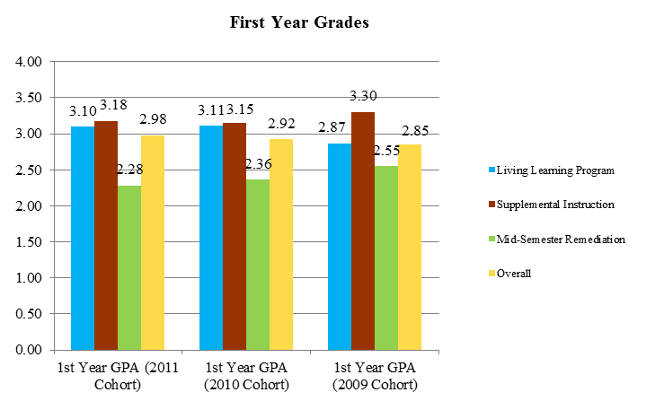
Chart 2: Retention Rates for Participants in the Closing the Achievement Gap Initiatives
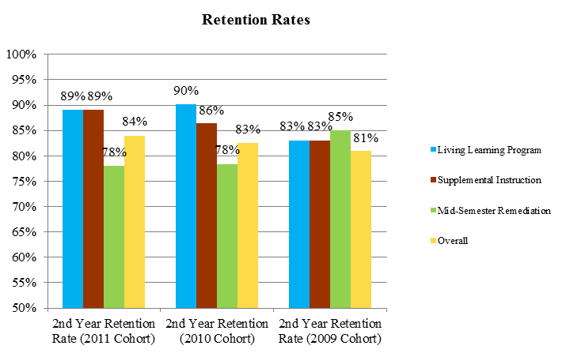
- Trajectory Demonstrating Intermediate Achievement Gap Goals

The following charts demonstrate the expected changes in six-year graduation rates for African American, low-income, and Hispanic students. The trajectories are based on closing the achievement gap between these subgroups and the University’s overall six-year graduation rates. Goals are set to close the gap in half by 2015 (2009 cohort) and eliminate it by 2020 (2014 cohort). Based on the successful implementation and funding of the initiatives a six-year graduation trajectory has been projected. Actual six-year graduation rates are charted against this projection to determine our progress towards closing the achievement gap.
Chart 3: African American Student 6-Year Graduation Rate Trajectory
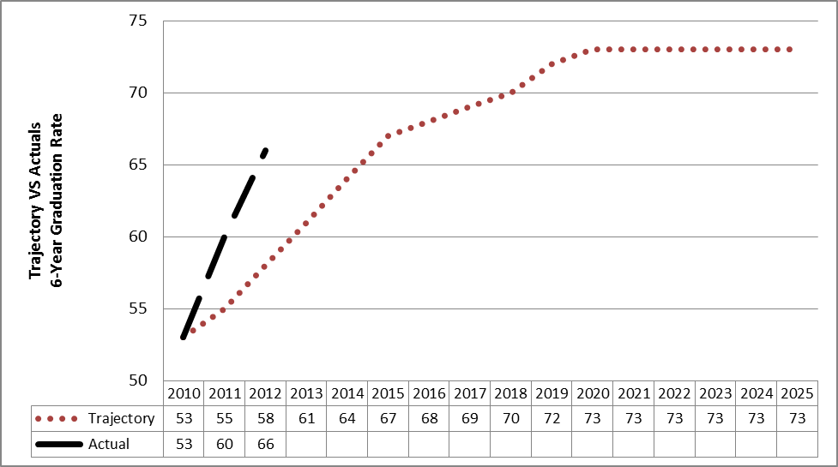
*Note. The trajectory is based on closing a 12 percentage point gap (2002 cohort) between African American and overall six-year graduation rates.

Chart 4: Low-Income (Pell Eligible) Student 6-Year Graduation Rate Trajectory
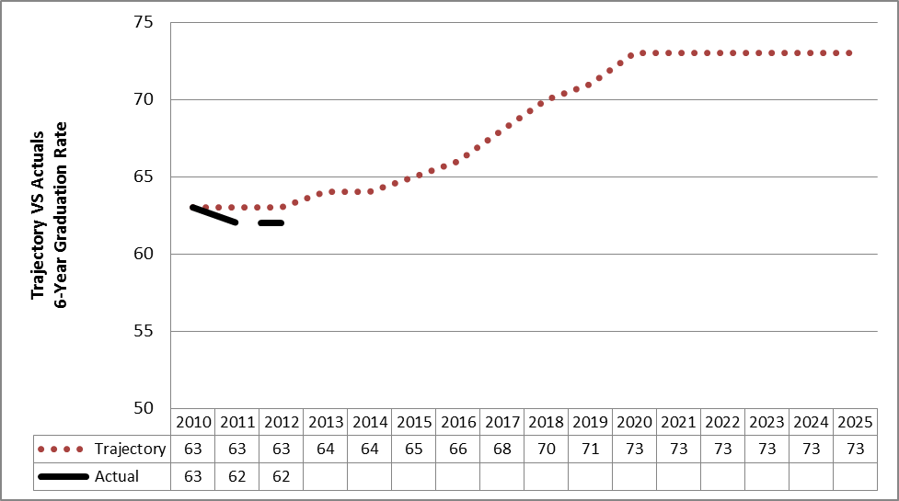
*Note. The trajectory is based on closing a 15 percentage point gap (2002 cohort) between low-income and overall six-year graduation rates.

Chart 5: Hispanic Student 6-Year Graduation Rate Trajectory
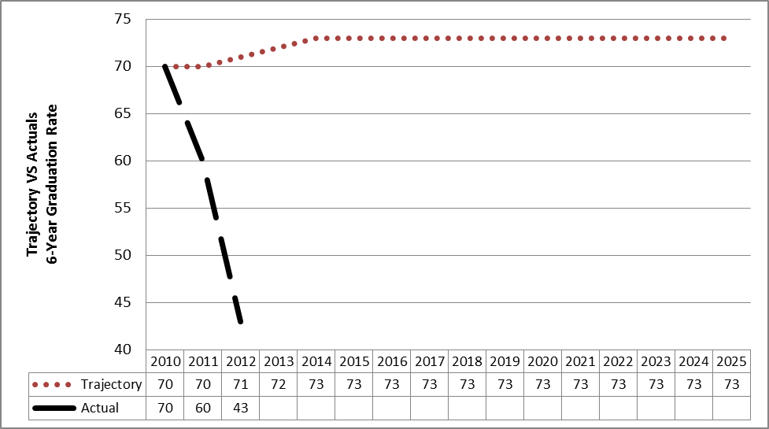
*Note. The trajectory is based maintaining the same six-year graduation rates for Hispanic and SU’s overall cohort of first-time, first-year students.

