

**Table of Contents**

1. Introduction to Navigate360 pg. 1
2. Navigate360 Help Center pg. 1
3. Logging into Navigate360 pg. 1-3
4. Home Page pg. 3

* Upcoming Appointments
* Recent Appointments

1. Availability pg. 4-7

* Adding Program Planning Availability
* Adding Office Hours Availability
* Copying and Deleting Times

1. Running Targeted Campaigns pg. 7-14
2. Opening an Individual Student Record pg. 14-21

* Overview
* Ways to Record Interactions
* Message Student
* Add a Note
* Report on Appointment
* Add to Student List
* Links
* Success Progress
* History
* Class Info

1. To Do’s pg. 21
2. Advanced Search pg. 21-24

* Student Information
* Enrollment History
* Area of Study
* Performance Data
* Term Data
* Course Data
* Assigned To
* Goals & Interests
* Surveys
* Success Indicators

1. Taking Action on Multiple Students pg. 24
2. Lists pg. 24-26

* Creating Lists
* Create List or add student through Advanced Search
* Upload List from a list of Student IDs
* Add Students to Student List form Student Profile

1. Navigate360 App pg. 27-33

* Instructions for Download
* Intake survey
* Screens shots: Landing Page, Checklists, Hand Raise, Study Buddies, Resources,

Active Holds, Courses-schedule View, List View

**Introduction to Navigate360**

Navigate360 is both an advising and communication tool. To start, faculty and staff can access information about individual students and groups of students more easily. In addition, they can communicate with students directly through the platform, and each interaction is recorded for other faculty and staff to see. Tracking notes and interactions creates a more complete picture of where the student stands and who else on campus is working with him/her. The goal of Navigate360 is to support students on their path to timely degree completion.

Students do not have access to the information found/recorded in the Navigate platform. However, all information is part of a student’s record and will be shared if the student requests it or if we are served a subpoena. Note: Be thoughtful about what you include and the language that you use.

If you would like to show a student something in the Navigate platform, you should scroll to the bottom of their Overview page and click “Student View.” You will know that Student View is activated when you see the button turn green. The Student View strips away the Predicted Support Level.

**Navigate360 Help Center**

This manual is meant to introduce you to Navigate360 basics. There is also a robust Help Center built right onto the Navigate360 platform. Access it by clicking on the “?” in the upper right-hand corner.

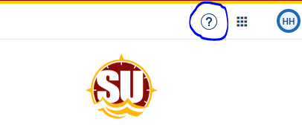

**Logging into Navigate360**

* There are four ways to access the Navigate platform.
* In all cases, use Chrome.
* In all cases, use your GullNet Username and Password to log in.
* Address – <https://salisbury.navigate.eab.com/staff>
* From the SU Homepage, under the Faculty/Staff tab, click on Navigate Platform

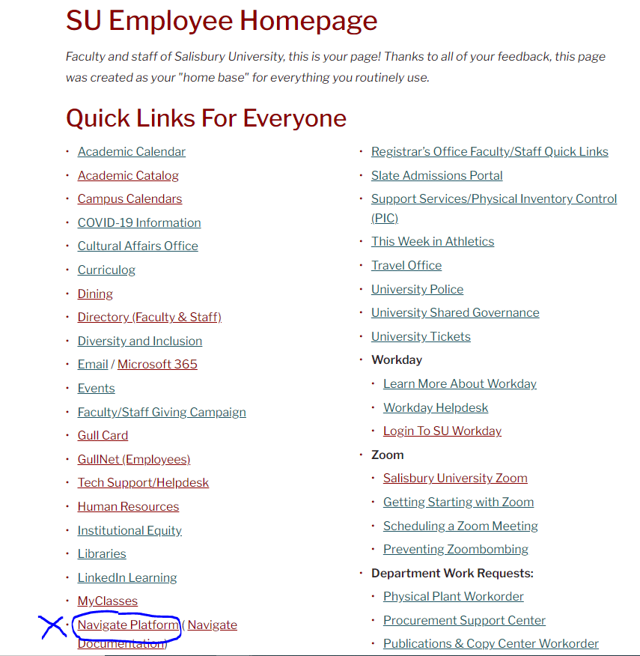

* On the GullNet Homepage, in the upper righthand corner, Navigate360 is one of the External Links

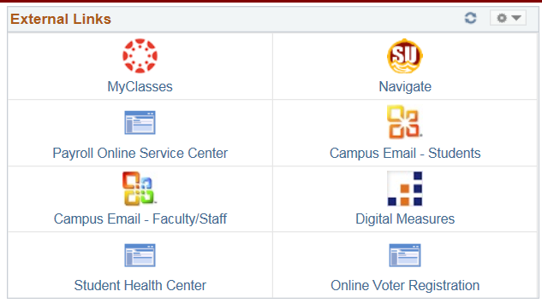

* In GullNet’s Student Services Center, there is a Navigate360 button on left side (see highlight below)

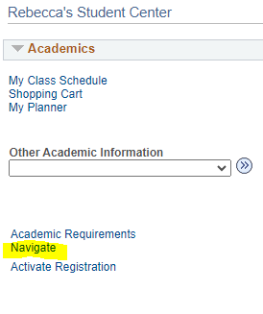

**Home Page**

After signing in to Navigate360, you are brought to a Home Page.

* The Staff Home shows advisees who are assigned to you.
* The Professor Home shows classes you are teaching and the students in your classes (Graduate and Undergraduate Students)

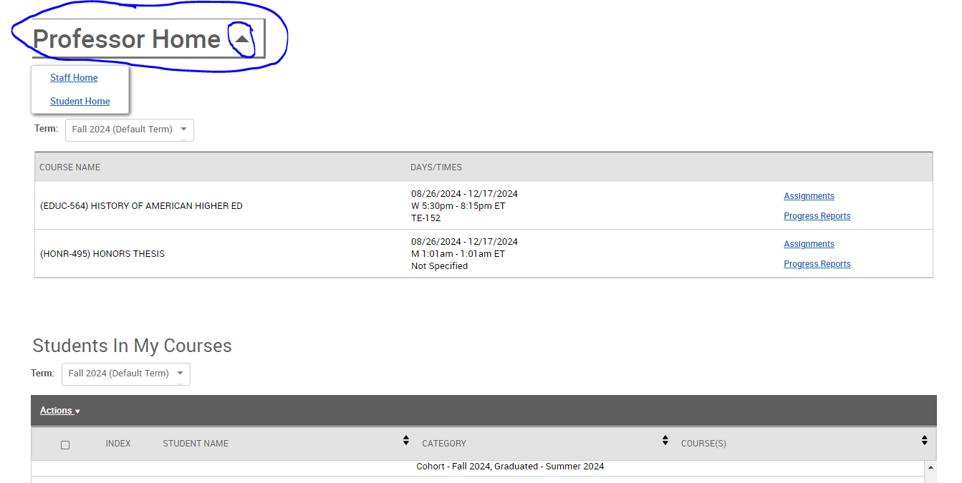

Professor Home

* You will see your courses for this term
* Students in your courses
* Assigned Students/Advisees
* Your Issued Notification/Referrals

Staff Home

* You will see students assigned to you/advisees
* Appointments- Will list anyone who has set up an appointment through Navigate360 Student to meet with you. Appointment reports will track anyone who you met with, and you filled out an appointment form for.
* Your availability
* Appointment Queues

**Availability**

The “My Availability” tab is where you set up your available times to meet with students. You can set up various times for diverse types of meetings (i.e.: Advising/Program Planning, Office Hours, etc.) You can set the appointments for a range of dates (Program Planning), a specific term (Office Hours), or make it never-ending.

NOTE:

* Program Planning appointment availability will no longer be done in GullNet.
* You can set up availability for multiple types of appointments: Program Planning, office hours, research mentorship, etc.
* If your availability is set up in Navigate360, students can sign up for an appointment through the Navigate360 student app.
* When students sign up for an appointment through Navigate360, they are sent an email reminder the day before and a text message reminder 30 minutes before.

You set up availability in Navigate360 so that students can schedule appointments to see you – or know when you are available for walk-ins. Separate (but overlapping) times can be set up for Program Planning, office hours, research mentorship, etc. Note that locations and services can be updated upon request, so contact Melissa Granger, Heather Holmes, or Sarah Timko-Jodlbauer if you would like to see something added.

**Adding Program Planning Availability**

**Step 1:** Across the top navigation bar, make sure the term is set to the term you are working with.

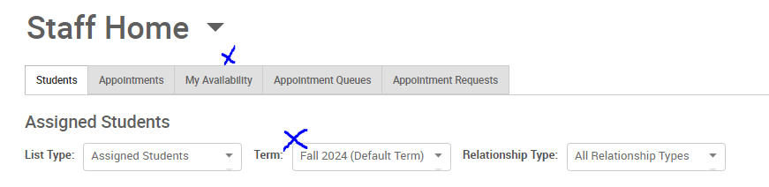

**Step 2:** Click on the third tab (My Availability) and choose Add Time in the Actions dropdown.

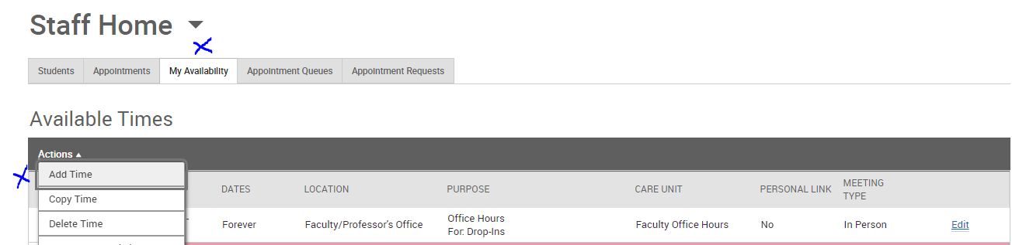

**Step 3:** Select the days and times when you are available to meet with students. (You do not have to block off your teaching schedule; Navigate360 already knows that you are not available at those times. However, you may want to block off the 15 minutes before and after class for travel time.) Navigate360 syncs with your Outlook Calendar and will not allow a student to schedule during blocked times (off campus appointments, meetings, etc.). During Program Planning be sure to keep your Outlook Calendar up to date.

**Step 4:** Select A Range of Dates. Program Planning dates can be found on the [Academic Calendar.](https://webapps.salisbury.edu/calendars/Program/all_calendars.asp)

**Step 5:** Click on “Appointments.”In addition, always click on “Campaigns” in case you decide to target students through a campaign (more information to follow). Note: For Program Planning, students must sign up for an appointment at least 24 hours in advance.

**Step 6:** Choose “In Person” and/or “Virtual” under Meeting Type. If you choose both, students can select their preference. When choosing virtual as an option be sure to provide your virtual link to under URL and in the Special Instructions for Student box.

**Step 7:** Choose “Advising” under Care Unit.

**Step 8:** Choose “Faculty Advisor’s Office” under Location.

**Step 9:** Choose either 15-Minute Program Planning, 20-Minute Program Planning or 30-Minute Program Planning, depending on how long a typical appointment lasts for you. If you would like students to choose the amount of time they think they need, you can choose more than one option.

**Step 10:** Enter any special instructions you may want to share with your advisees (e.g., Office located in Henson Hall Room xxx; Please come prepared with a list of courses you plan to take in the spring; etc.)

**Step 11:** Leave Max Number of Students per Appointment set to 1.

**Step 12:** Click the Save button.

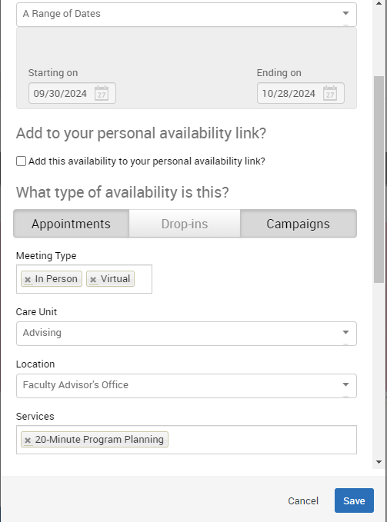

**Adding Office Hours Availability**



**Step 1:** Click on the third tab (My Availability) and choose Add Time in the Actions dropdown.

**Step 2:** Select the days and times when you plan to hold office hours.

**Step 3:** Select Fall 2024 (Default Term) in the “How long is this availability active?” dropdown.

**Step 4:** Click on “Appointments” if you are willing to have students make appointments during your office hours. Click “Drop-ins” if you prefer for students to drop in instead of signing up in advance. You may click both if you are ok with either. In addition, always click on “Campaigns” in case you decide to target students through a campaign (more information to follow).

**Step 5:** Choose Meeting Type (In Person, Group, Virtual or all modes)

**Step 6:** Choose “Faculty Office Hours” under Care Unit.

**Step 7:** Choose “Faculty/Professor’s Office” under Location.

**Step 8:** Choose the appropriate service you plan to provide to students during your office hours. You can list a specific time or leave it open by simply choosing “Office Hours.”

**Step 9:** Courses-select the course GENL-103 if applicable

Step 10: Enter any special instructions you may want to share with your students (e.g., Office located in Perdue Hall Room xxx; If you are bringing snacks, I prefer dark chocolate; etc.)

**Step 10:** Change the Max Number of Students per Appointment if you are willing to meet with more than one student at a time.

**Step 11:** Click the Save button.

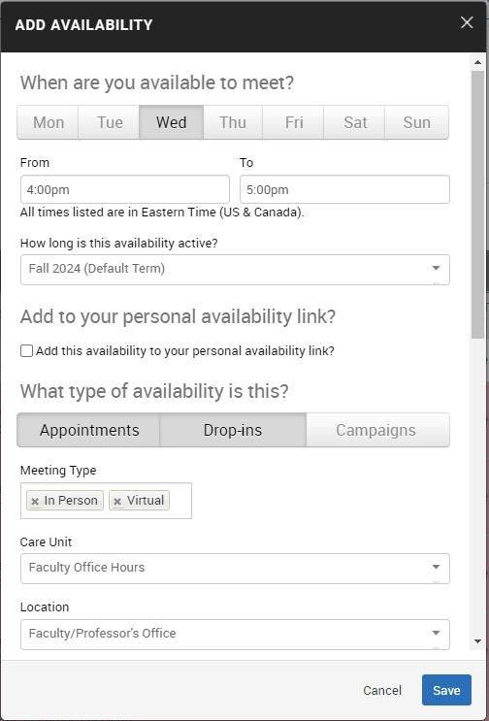

Other Available Times Options…

**Copy Time** - To copy a time, select the time you would like to copy and then click the Copy Time button. The availabilities will be copied, and a dialog will open allowing you to make edits or to save your newly created availability. (If your original time had a range of dates, you will have to update them in the updated version.)

**Delete Time-** To delete your time, simply select the time and click the Delete Time button.

**Note:** Inactive availabilities are highlighted in red in the Times Available grid. That simply means that we are outside of that period. However, students can see the times you have set for the future and are able to set appointments for those times before they are active.

**Running Targeted Campaigns**



An Appointment Campaign allows faculty and staff to contact specific populations of students to encourage them to schedule appointments. This functionality is commonly used when you have identified a population of students in need of additional support, and you are sending them a request to schedule an appointment with you. **Program Planning is a perfect time to run a campaign.**

**Launching an Appointment Campaign**

To begin, click Appointment Campaigns in the Actions or Quick Links menu.

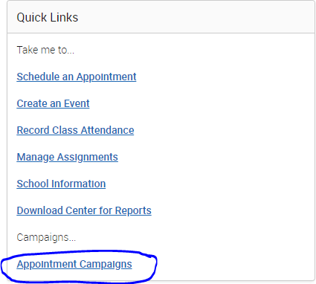

In the Actions menu, choose the type of Campaign you would like to run. In this case, choose Appointment Campaign.

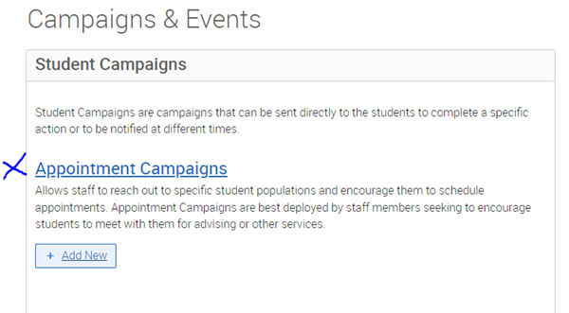

**Define the Campaign**

In this step, you will set the criteria for your Appointment Campaign. The fields that must be filled out are listed and defined below. Note that if other staff are going to be included in this campaign, the reason/location/date range must align with Campaign Availability for the advisor(s) that are going to be included in the campaign. **Care Unit, Location, and Service must match your already set availability, or students will not be able to schedule an appointment.**

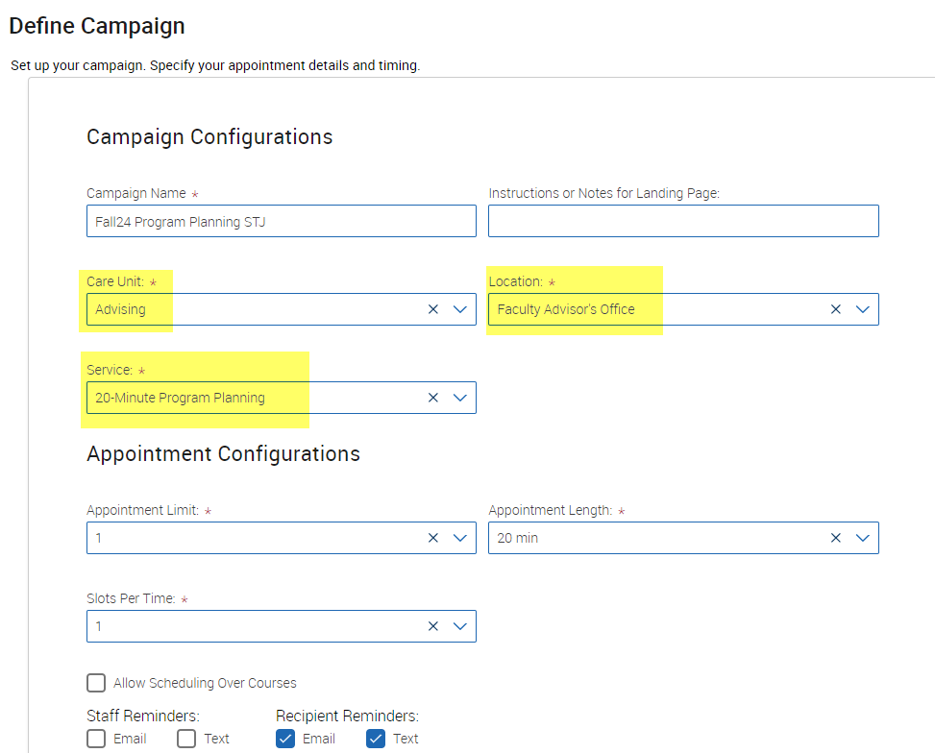

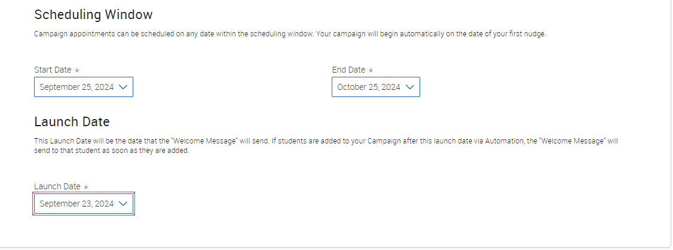

* **Campaign Name:**Campaign Name is visible to the person creating the campaign and any other users who have access to view campaigns; it is not visible to the student. Make sure to adhere to SU’s naming convention. It will make it easier to track the impact of your campaigns.

Include the following in your name: Term, College, Purpose, Last name of user who created the campaign (Example: Fall24 Seidel Program Planning Holmes).

* **Care Unit:**Select the Care Unit the Appointment Campaign will be associated with.
* **Location:**Select the location of where the appointment(s) will be held.
* **Service:**Select the Service that will be associated with the campaign.
* **Appointment Limit:**This will determine how many appointments you wish for the student to schedule during the campaign.
* **Appointment Length:** This is where you define exactly how long the appointment will be.  Durations begin at a 5-minute length and will be determined by your configuration.
* **Slots per Time:**Appointments can be individual or group. By adding more than one "slot per time", you can have a group appointment.
* **Scheduling Window:** These are the dates that you want students to start and stop making appointments for the campaign. Your campaign will begin automatically on the date of your first nudge.

**Select Recipients (Add Students to Campaign)**

After entering the details on the Define Campaign page, click Continue.

Your next step is adding students. If you created this campaign directly from a list or Saved Search, you will be asked to review your students. If not, use Advanced Search to pull a population. To pull your advisees go to Assigned To, select Advisor, and search your name, click Continue.

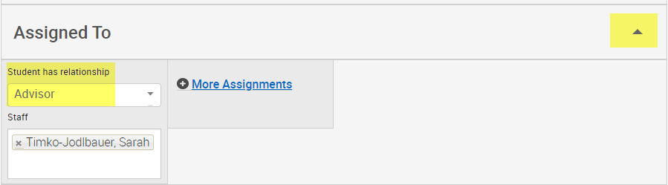

If you choose the Advanced Search option,you will be presented with a list of students and must select the students you wish to add, click Continue. You can add more recipients at the bottom of the page.

You can remove students from the campaign if needed. For example, if you met with one of the students already and do not need them to come in during the campaign period. They can be removed by unselecting the check box next to their name.

Once finished, click **Continue** to move to the next page.  You will be asked to review the students in the campaign. If these are correct, click **Continue**.

**Add Staff to Campaign**

You will need to select yourself as staff for the campaign. You may also select additional staff to make them available for appointments based on the campaign.

NOTE: Staff will need to have availability defined before they can be added to an appointment campaign. If you do not see staff you expected to have availability, make sure their calendars and availability are up to date.

**Compose Your Message**

Your next step is to compose the message that you will send to students. DO NOT REMOVE THE SCHEDULE LINK FROM THE EMAIL BODY.

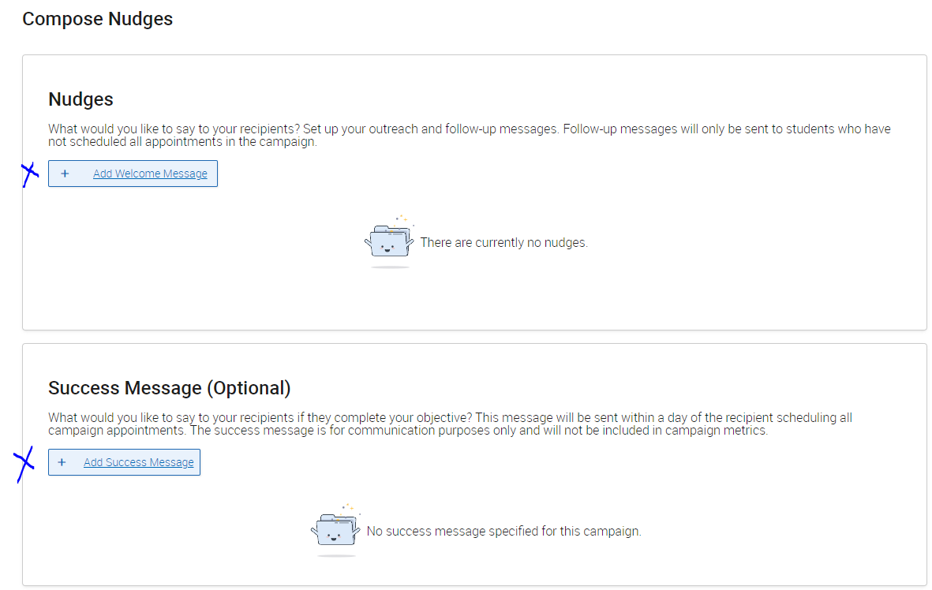

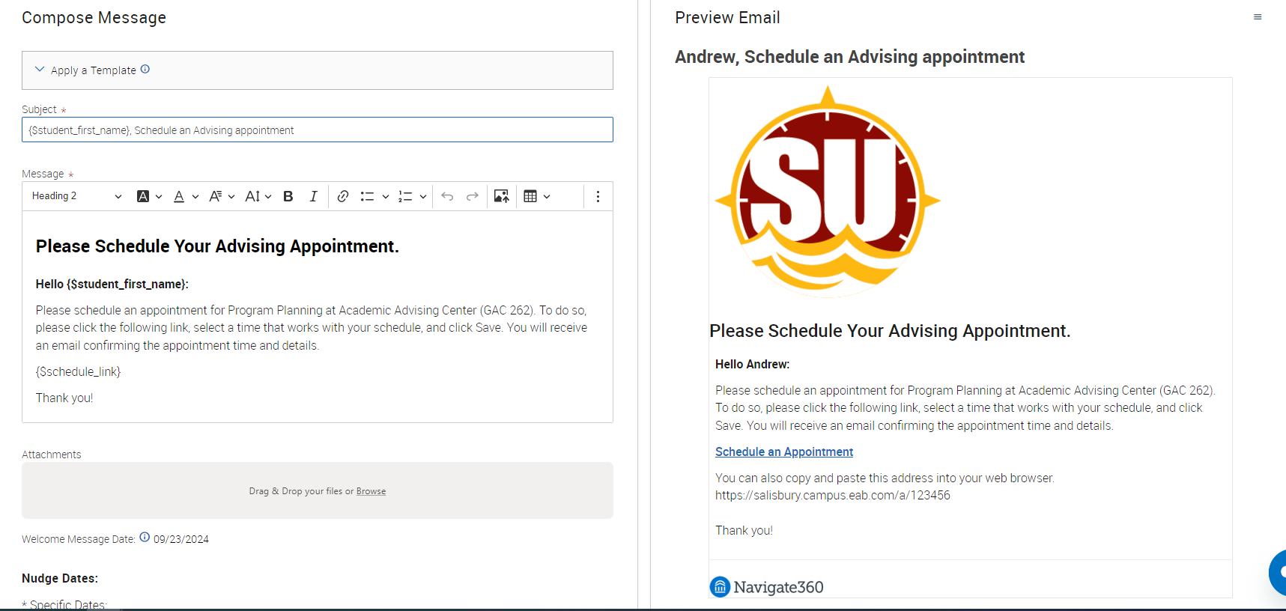

Fields used in the message composition are:

**Email Subject:** The topic will be the subject of the email going to the student.

**Message:** Compose a message to the student

**Instructions or Notes:** This will be specific to the landing page students will be taken to when they click on the link in their email to choose the date and time of their appointment. Be sure to include the Schedule Link {$schedule_link}

Note that you can include attachments.

You can preview how the email will look as you create the message.

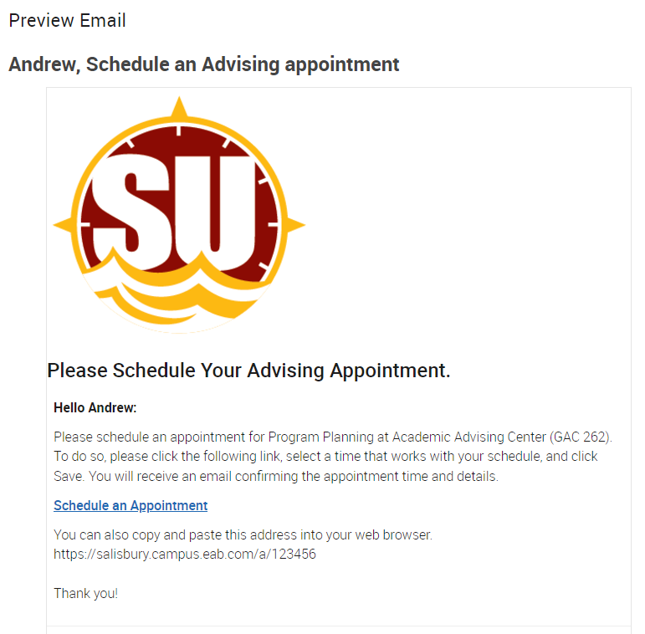

**Compose Nudges:** Set up your outreach and follow-up messages.

After you have finished composing and previewing your message and setting up nudges, it is time to send out your campaign!

**Verify & Start:** Review your campaign details, recipients, staff, and welcome message on this page.

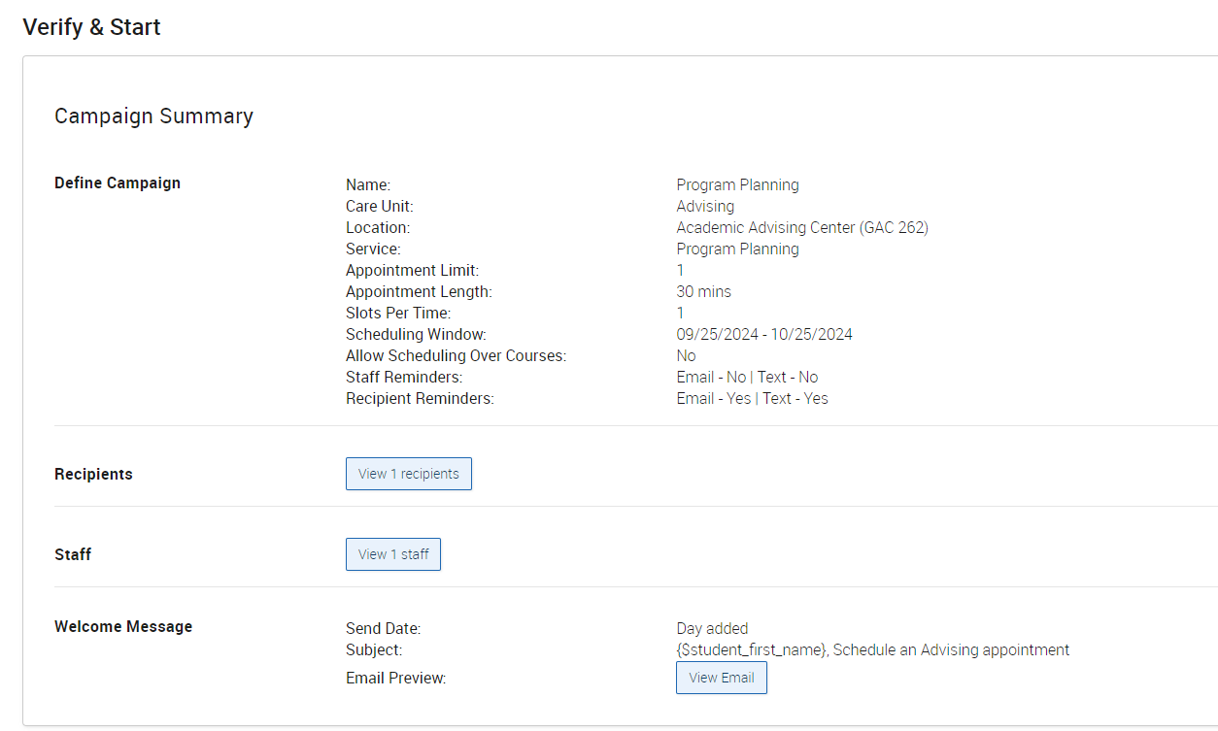

Click **Start Campaign** when you are ready to email the invites to the selected students.

**Managing Your Campaign**

The platform gives you tools to manage your appointment campaign once it has been created and sent.



On the Appointment Campaigns tab, you will see three at-a-glance statistics if the campaign is active: Appts. Made, Reports Created, and Attend. Rate.

Here are the definitions for these metrics:

* **Appts. Scheduled:** the % of appointments scheduled by students on the outreach list
* **Appointments Attended:** the % of the appointments attended
* **Summaries Created:** % of summary reports created for those appointments

To see more details, select an Appointment Campaign name to drill into.

This page allows you to edit or delete the campaign. It also gives you crucial information about the campaign, broken down into four tabs of information, described below.

**Appointments Made:** This tab lets you see which students have made appointments. Not only can you view those students individually by selecting their name, but you can also Send a Message and/or Add Note for an individual student or for the group.

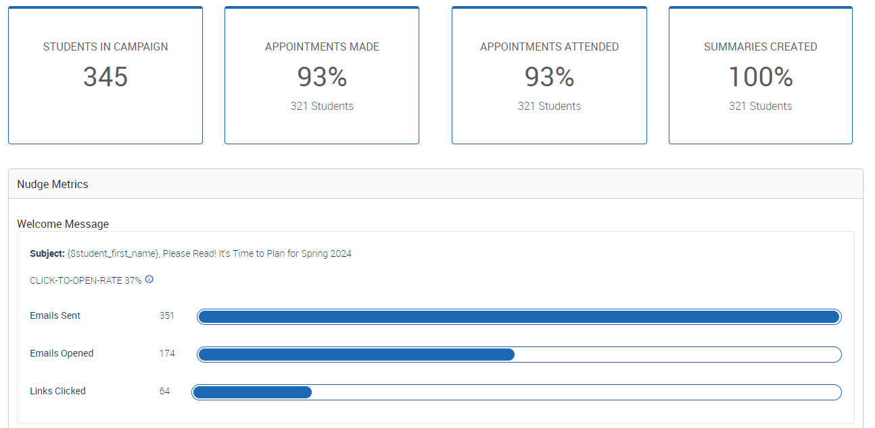

**Appointments Not Yet Made:** This tab will display those students who have not yet made their appointment(s). The Actions menu allows you to Send a Message, Add Notes or Add Tags for the students individually or as a group.

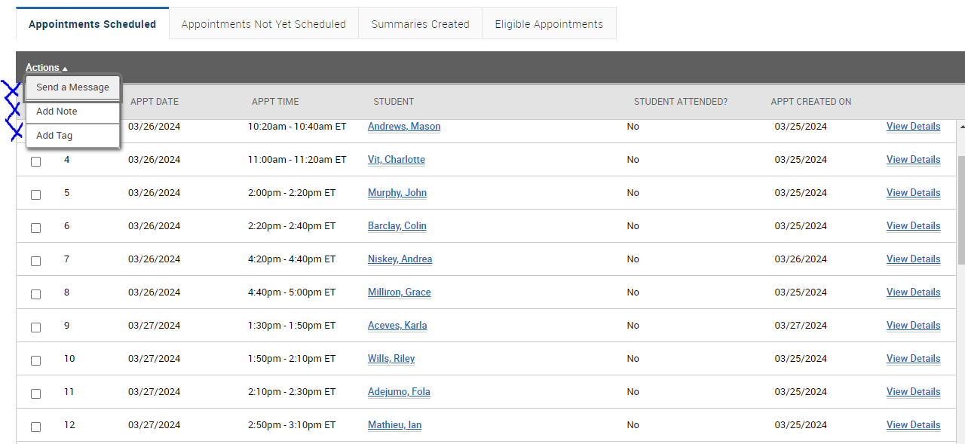

**Summaries Created:** This tab will list any summary reports made from the campaign. From this tab you can view the detailed report. You can act by clicking the Actions tab to send a message, add note, or tag.

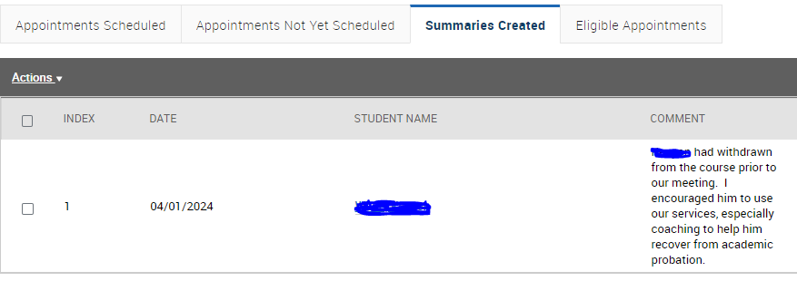

**Opening an Individual Student Record**

You can click on a student in your Home Page list or Search for a student by name or ID# in the search bar at the top of the page.



Overview

Dashboard Features Include:

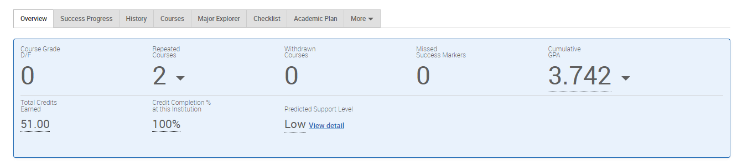

**Course Grade D/F** shows if a student has earned a D or F and which courses.

**Repeated Courses** include Special Topics courses, so it is not always a negative indicator when students repeat. Open the dropdown to see the detailed list of courses.

**Withdrawn Courses:** Courses the student has withdrawn from.

**Missed Success Markers:** Student guidelines for progress. Acting on them can help get the student on track for successful completion.

**Cumulative GPA:** Based on the courses the student has taken at SU. Transfer grades are not included.

**Total Credits Earned:** Includes Salisbury University and external credits earned at other institutions.

**Credit Completion** % is only based on the courses the student has taken at SU. Transfer credit is not included.

**Predicted Support Level**

* The Predicted Support Level indicates the likelihood of a student persisting to the next fall term. This is based on the outcomes of students with similar attributes within SU’s historical student population. This is calculated using influencers relating to the student’s academic performance, progress, program of study, pre-enrollment data, and other factors. This does not always mean a student is not performing academically; it could mean they are high achieving, and the historical data indicates the student may transfer to another institution.
* The Support Level is not a crystal ball! It is a starting point for conversation.
* The Student View removes the Predicted Support Level (and other things) from the display.

**Goals and Interests** are pulled from information students provided through the Navigate360 Student app.

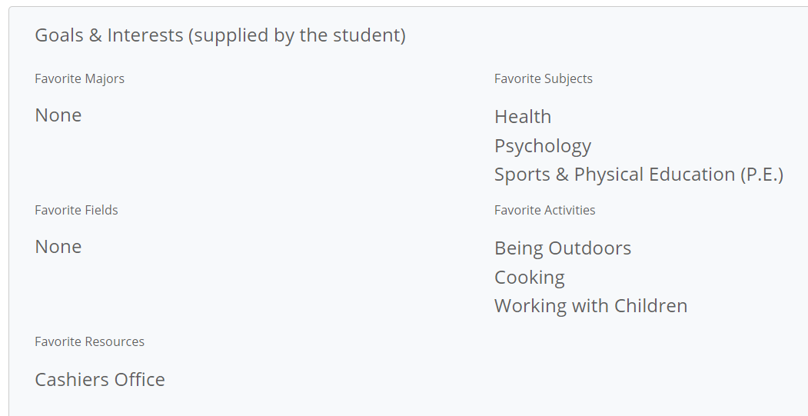

**Categories** show a snapshot of specific features of a student’s profile (i.e. – Academic Standing, Admit Type, their Cohort/term they matriculated, declared minor, whether they are involved with an LLC (Living Learning Community), Trio, Powerful Connections, etc.)

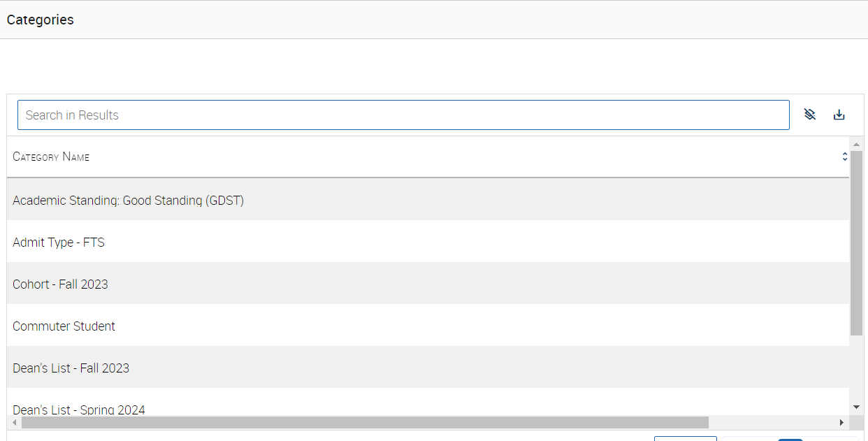

**Tags:**

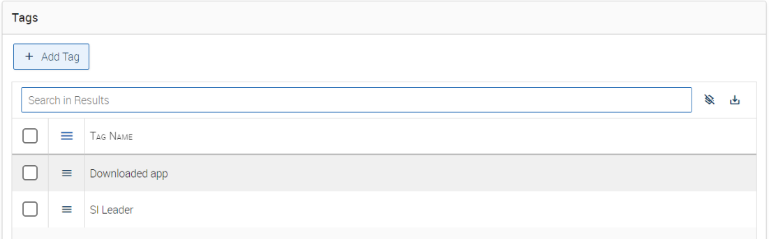

**Ways to Record Interactions**

There are many ways to act on a student. They are listed on the right-hand side of the student page.

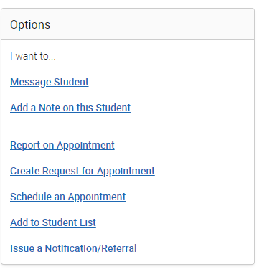

Message Student

* You can send an email to a student (including attachments)
* Messages you send are recorded under the “More” tab under “Conversations”
* If a student responds, his/her response is also recorded there
* Your messages will also appear in your Outlook inbox and outbox. Note: They only appear in both places if the initial email was sent through Navigate360.

Add a Note

* You can add notes to a student’s record (including attachments)
* It defaults to everyone (other than the student) being able to see the note; this is often a best practice
* These notes will be saved in the student’s History
* You can select your name only under “Visibility” if you want the note to only be visible to you. You should choose this option when your note references the Counseling Center or Disability Resource Center.
* You can choose the student’s name under “Visibility” if you want the note to appear in Student View.

Report on Appointment

* If a student stops in for an appointment (without scheduling one through Navigate360 in advance) you can record your interaction through the official report form.
* Once you choose a Care Unit (i.e.: Advising, Office Hours), some of the reports will populate for you and you will be prompted to answer a few questions.
* If you choose to fill out the report after the appointment is over, remember to change the meeting start and end time.
* This report will be saved in the student’s History and can be viewed by anyone who has access to the platform. The student cannot see the Appointment Report.

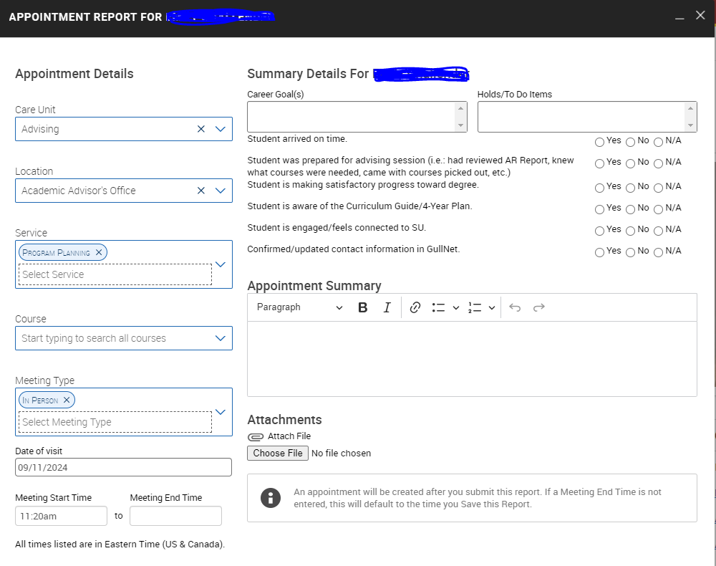

Create Request for Appointment

* Request that a student meets with you to discuss a class in office hours or for program planning.

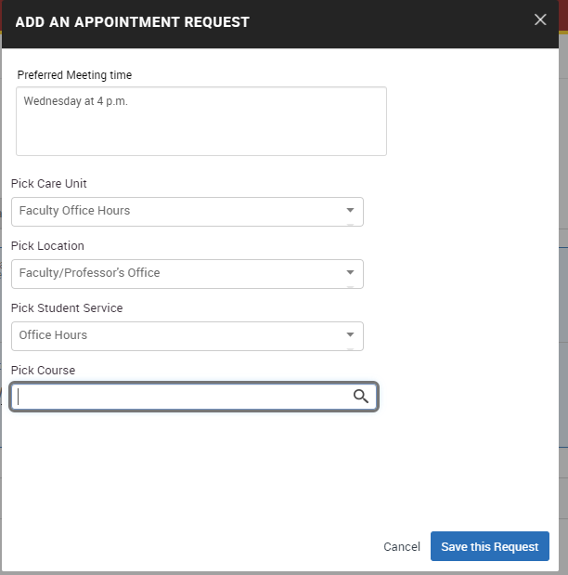

Schedule an Appointment

You can manually schedule an appointment for an individual student.

When in an individual student’s record, click on “Schedule an Appointment” from the right-hand menu.

Add to Student List

From the individual student page, you can manually add a student to a Student List. A Student List is a static list of students. You can create multiple Student Lists. This feature is best when you would like to track students' overtime.

Issue a Notification/Referral

Faculty and staff can issue a notification/referral at any time during the semester. Notifications/referrals connect students to support systems across campus for various reasons, such as academic or participation concerns, tutoring needs, sending academic kudos, connecting to study abroad opportunities or financial barriers. Issuing a notification/referral will prompt action from the appropriate department to try to connect with the student to provide support.

Links

The Links area contains links to outside sources. Currently you can move directly to GullNet and the Curriculum Guides. Links are listed in the Links box on the right side of the student page. If you have a suggestion for another helpful link, please contact Melissa Granger.

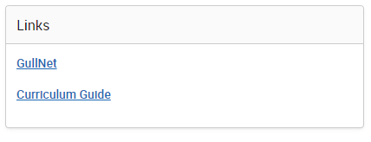

The tabs across the top of the screen provide more information about the individual student. Based on your permissions within Navigate260, you may not have access to all tabs.



Success Progress

Under Success Progress you can view completed, missing, or upcoming Success Markers. You can also view a graph of GPA Trends by term and Credit Trends by term.

Success Markers are courses critical to progress in the student’s major. It may be the course itself, the grade, or the timing that is especially important.

History

History will show any notes or reports added by faculty and staff.

Courses

Courses include classes this term and a full transcript, including courses, grades, term and cumulative GPAs, academic standing and transfer courses/grades, high school name, and standardized test scores.

Major Explorer

Major explorer connects to the student app and desktop and allows students to explore majors and careers. Search for careers related to their major, wages and employment trends. It also lists the top 20 most important skills employers are looking for. The information source is o*net Online sponsored by the U.S. Department of Labor.

Checklist

List of events and to-dos for students to complete or be reminded of related to their social and academic transition to college. Students can also add and create their own checklists in the Navigate360 app.

More

Under “More” you will find Calendar, Study Hall, Appointments, and Conversations.

* Calendar

The calendar shows the student’s class schedule in a monthly calendar format including the class location.

* Study Hall

The Study Hall features records time student-athletes log studying in the Center for Student Achievement (CSA) or Library. CSA peer leaders also log-in time here for session planning. To add a study hall for your team or organization contact Heather Holmes.

* Appointments

Shows any recent or upcoming appointments that the student has scheduled.

* Conversations

The Conversations tab tracks emails and texts sent through the Navigate360 platform and the student’s response(s).

**To Do** 

You will find To Do’s under the thumbtack icon on the left menu. These are to do’s you set for yourself. When on an individual student’s page, you can add a to do about this student and assign a due date. When you click on the to do icon, any to do that you set for yourself will be listed there.

**Advanced Search**



You will find Advanced Search under the magnifier icon on the left menu. By choosing criteria, you are creating a query.

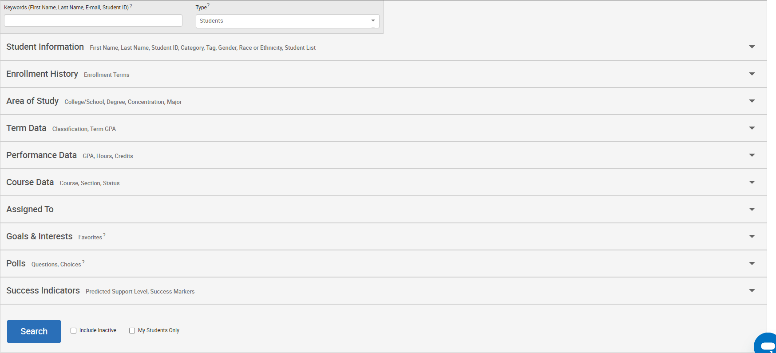

New Search

You will find the breadth and depth of the advanced search features listed under this heading.

My Students Only

Click “My Students Only” if you only want your criteria to pull from the list of students assigned to you.

Include Inactive

Click on “Include Inactive” if you want to pull inactive students as well as those currently active in the system.

Student Information

Click on student information to search by First Name, Last, Name, Student ID, Category, Tag, Gender, List.

Tags

Tags provide more information about a student and can be added by any user. Tags are static and remain within Navigate360 until deleted by a user.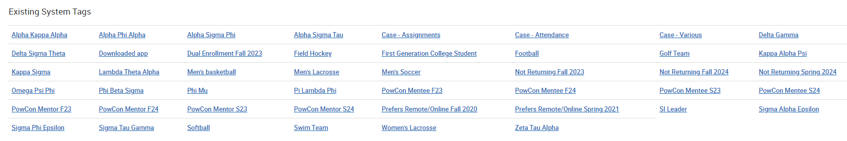 New tag options are added by the CSA or Advising Center by request. Reach out to Heather Holmes or Sarah Timko-Jodlbauer for more information.

Categories

For search options that were not delivered in the platform, Categories were created. If you know what you are looking for, you can start typing in the category – rather than scrolling through the list. Categories that are currently available:

* Academic Standing (Good Standing, Probation, Restricted, Dismissal)
* Admit Type (FTS (First Time Students), GSD, IFT, ITR, TRN, USB)
* Cohorts (aka - Matriculation Term)
* Commuter Student
* Discontinued
* Expected Graduation (Term students applied to graduate)
* Honors College (Honors College and School-Specific Honors Programs)
* International Student
* Minor (Since we can only search by major in Area of Study section)
* Near Complete (Has 100 credits or more)
* On Campus
* Part-Time (Between 1 – 11 credits)
* Powerful Connections (By Cohort) recent years found above in Tags
* Pre-Professional (Each of the Pre-Health and Pre-Law tracks are designated)
* Suspended
* Transfer GPA less than 2.5 (Students who transferred in with less than a 2.5 overall)
* Trio (All students currently enrolled in Trio)
* Undecided Majors
* Veteran and Military Connected

Note: If there are Categories you want as options not available, contact Melissa Granger with suggestions.

If you hit the “+” button beside Category, you have the following options: “In All of These” and “In None of These”

Enrollment History – If you only want students enrolled in a specific term; terms go back to 2013.

Area of Study – Options in study search include College/School, Major, Concentration, and Degree. Note: “In Any” means “or” “In All” means “and” and “In None” means that are not in any of these.

Performance Data

Search under these criteria by minimum cumulative GPA, maximum cumulative GPA, minimum credits earned, maximum credits earned, minimum hours attempted, maximum hours attempted, minimum credit completed, and maximum credit completed (%). Minimum HS GPA and Maximum HS GPA are included, but we do not have that info for transfer students.

Term Data

Within a specific term, search for minimum credit hours, maximum credit hours, enrolled with professor (lists each professor’s name), classification (Freshman, Sophomore, Junior, Senior, Adult Education, Continuing Education, Skills, Credits, and Other).

Course Data

Find info on courses within a term or over multiple terms. You can find students who are registered, have withdrawn, or have earned specific grades in specific courses. Search course data by each course (i.e., BIOL 310 Ecology, ENGL 221 Literature & Film, etc.) within a term or within a range of terms.

Assigned To

Search for students Assigned to a specific Advisor (populated with all academic advisors and faculty mentors).

Goals and Interests

This search field is currently under construction.

Surveys

This search field is currently under construction.

Success Indicators

Search under Success Indicators to sort by Predicted Risk level (low, moderate, high, and unknown).

**Acting on Multiple Students**

At any point, if you have a list of students, you can act on all of them. Click on All to choose the full list. If your list contains more than 100 individuals, you must indicate that you want the full list included. Once your students are selected, choose the action you want to take from the dropdown menu.

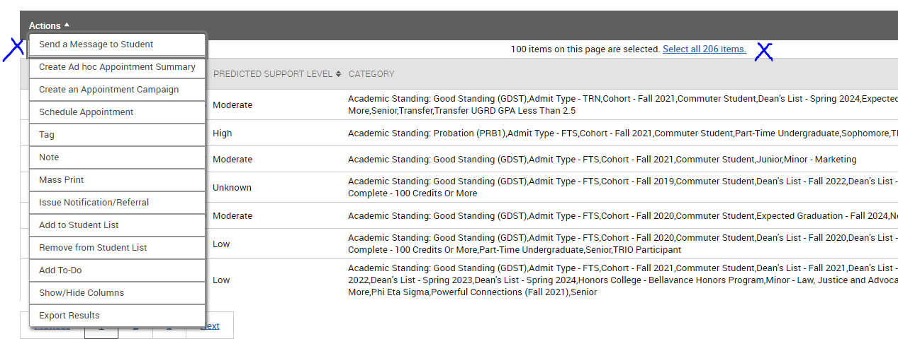

**Student Lists**



A list is a static list of students by student ID. Even as student information changes, the list of students will remain the same. Use Student Lists to track information about a group of students. You will find Student Lists, Saved Searches and Saved Reports under this icon in the left menu. Click on New Student List to create a list. Name the Student List. When naming Student Watch Lists include anything to help identify the qualities of the list. For example: F19 USAL HWH “All Undecided students enrolled for Fall 2019” and my initials

There are three ways to create a Student List:

**Option 1 - Create Student List or add student through Advanced Search**

1. Select Add to Student List
2. Add student to an existing list or select create new list
3. Once you name your list, click Save. You have saved a static list of students that will not change over time.

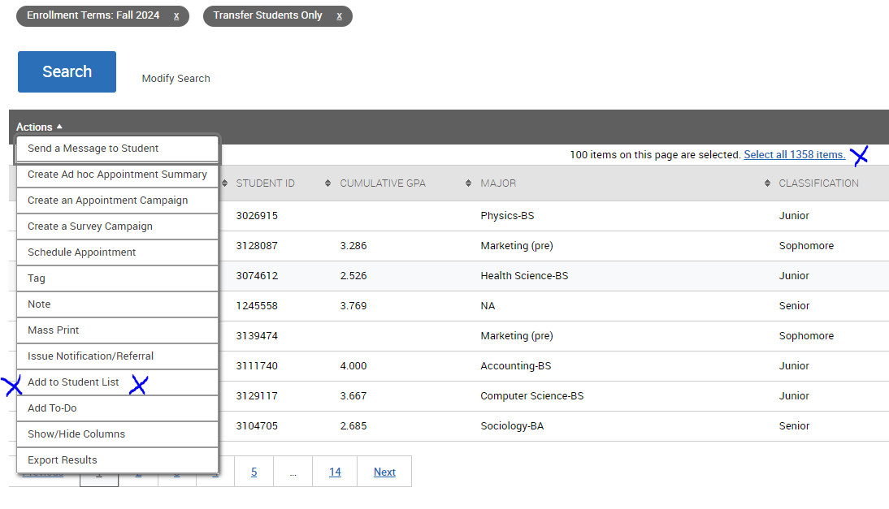

**Option 2 -Upload Student List from a list of Student ID’s**

You can also upload a list of students into the Navigate360 platform from Excel to create a Student List. Note that the Excel file must be in a Comma Separated Values (.csv) format.

1. Open Navigate Staff
2. Naviage to the Student Lists and Search page.
3. In the Actions menu of Student List, select Upload Student List.
4. Create a new Student List or add the student in your ist to an existing Student List.
5. Select the file and upload it.
6. Choose the column that represents Student ID and then finish the import.

**Option 3- Add Students To Student List from Student Profile**

1. On the right-hand side of the student profile page in Navigate360, use the Actions box to select “Add to Student List”
2. From here you can choose which student list to add it to or create a new student list and add the student to it.

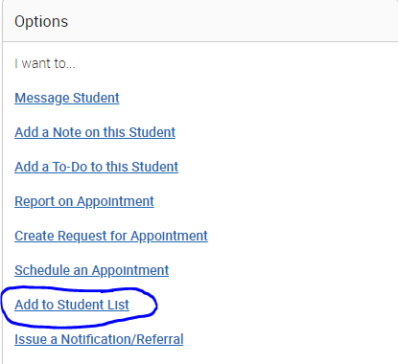

**Navigate360 Student App (for students only)**

Although students do not have access to the Navigate platform, they do have access to a mobile app.

**Instructions to download the app (students only)**

* Open App Store or Google Play on your phone
* Search for “Navigate Student”
* Download (App takes the space of one selfie)
* Open App
* Search for Salisbury University
* Log in (using your Gullnet username and password)

**Then…**

* Go to settings
* Under My Stuff, click on Notification Settings
* Choose your preferences
* Recommended-Under Personal Reminders and Must Do Steps, opt in for Push Notifications and Text Messages

There is also a desktop version of the app. The link can be found on SU’s Homepage, under the Current Students tab. It is called Navigate Student.

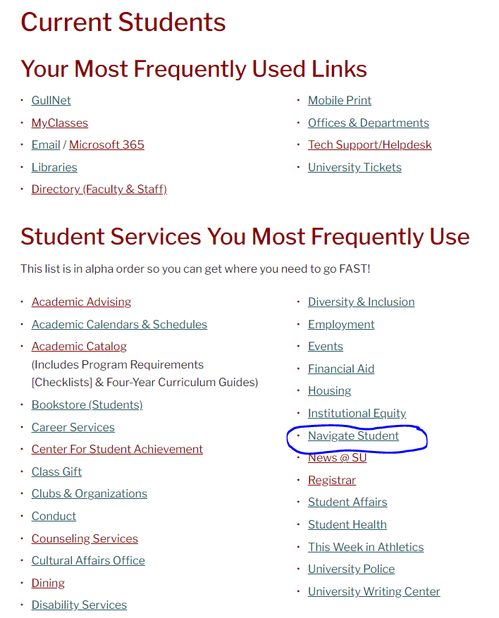

The first-time students download the mobile app or open the desktop version, they are prompted to take a quick **Intake Survey**. Survey questions currently include:

I am interested in the following:

* Getting a job on campus
* Getting involved on campus
* Finding out about internships
* Studying Abroad
* Volunteering and/or community service
* Joining a fraternity or sorority
* Participating in undergraduate research
* Exploring career options
* Taking a summer or winter class
* Running for Student Government

I would like more information about (select all that apply)

* Paying for College
* Academic support-tutoring, study groups
* Accommodations and resources for students with disabilities
* Counseling and mental health services
* The University Writing Center

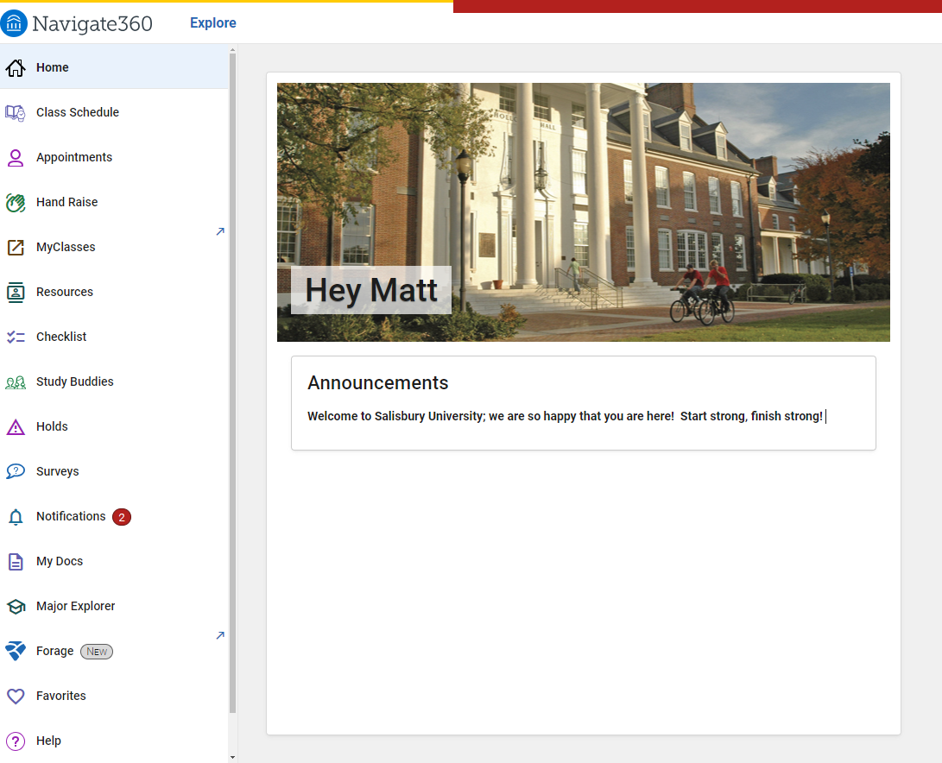

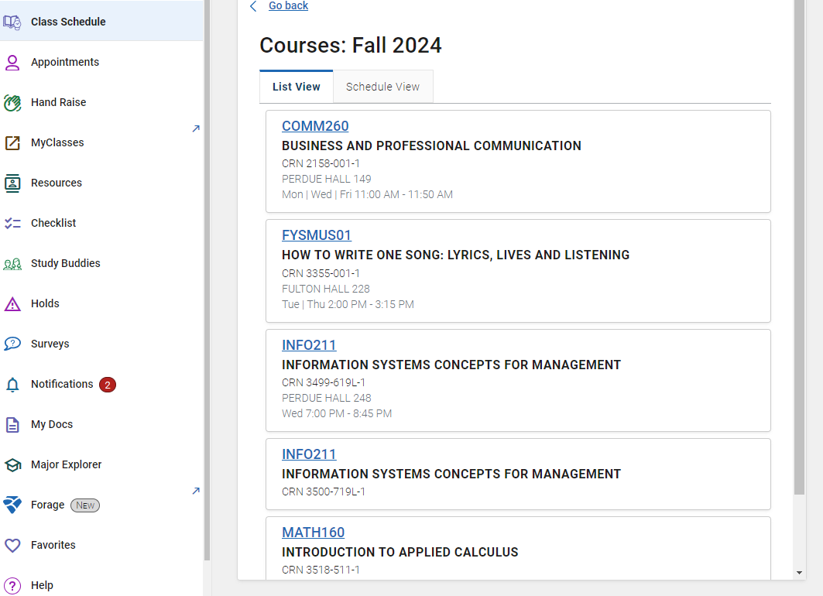

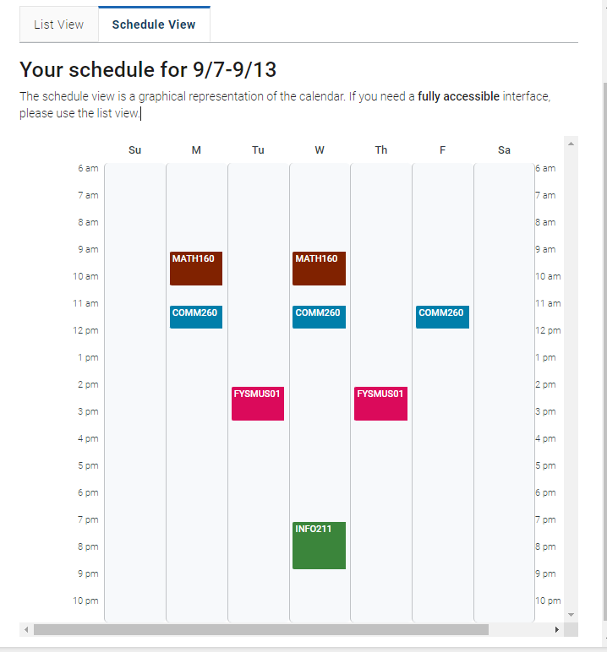

**Self-referral:** Students can raise their hand to tell us that they need assistance with:

* I have financial concerns; connect me to Financial Aid
* I need help with advising
* I am struggling in one (or more) of my classes
* I am thinking about dropping one of my classes

A staff member from the appropriate office will reach out and respond to the students and get them connected to the appropriate resources.

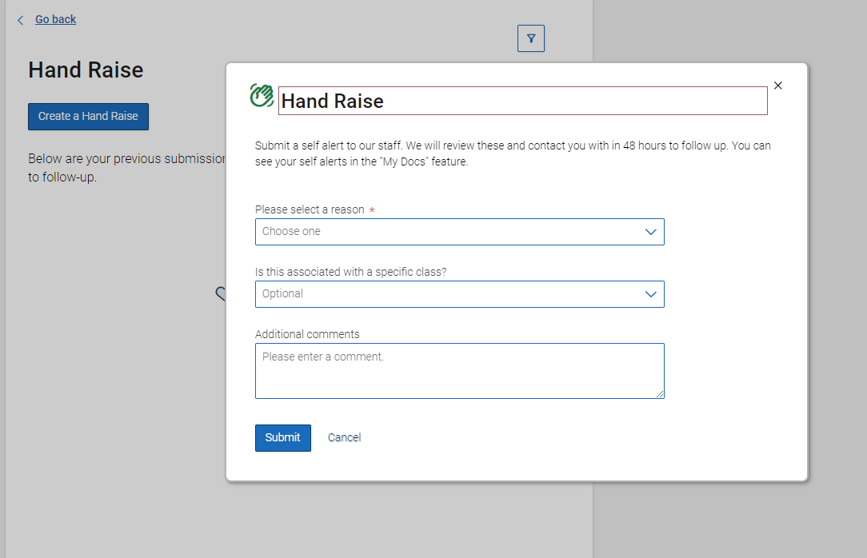

**MyClasses** connects the student to their MyClasses pages

**Resources:** connects students to Places on campus and People who are part of their care team (academic advisor and professors).

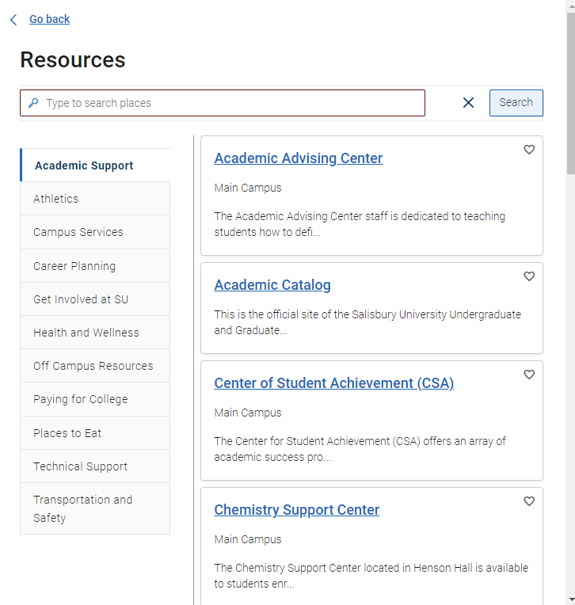

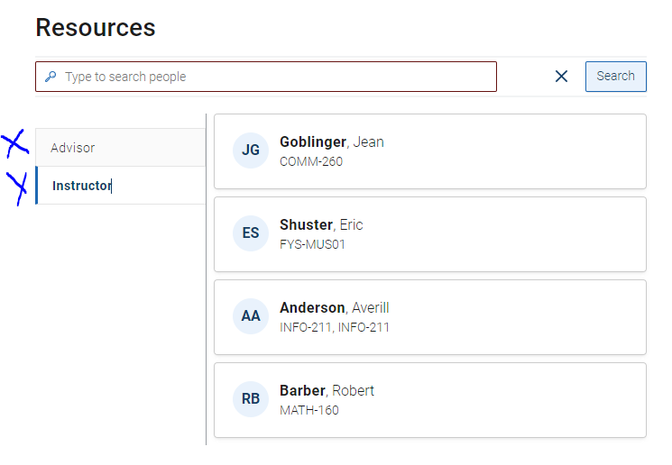

**Checklists:** Students can create their own items; staff also create check-list items to help the student get involved and transition both academically and socially. To add to events and to-do’s contact Heather Holmes in the Center for Student Achievement.

u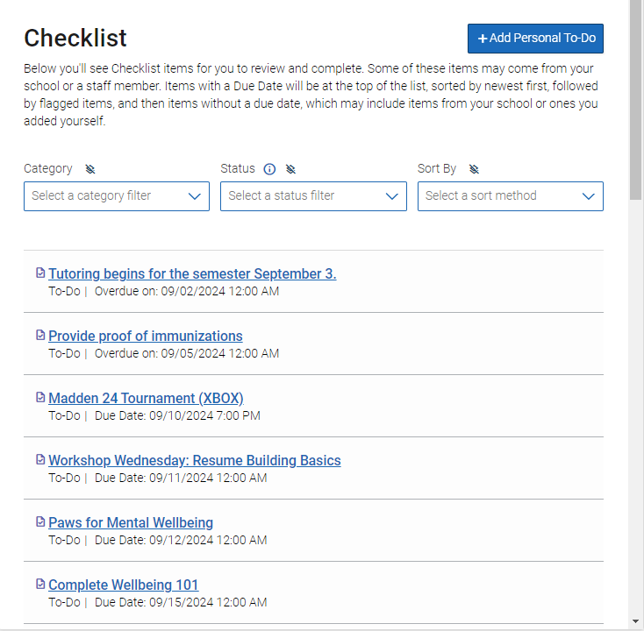

**Study Buddies:** Students can connect with classmates to create study groups.

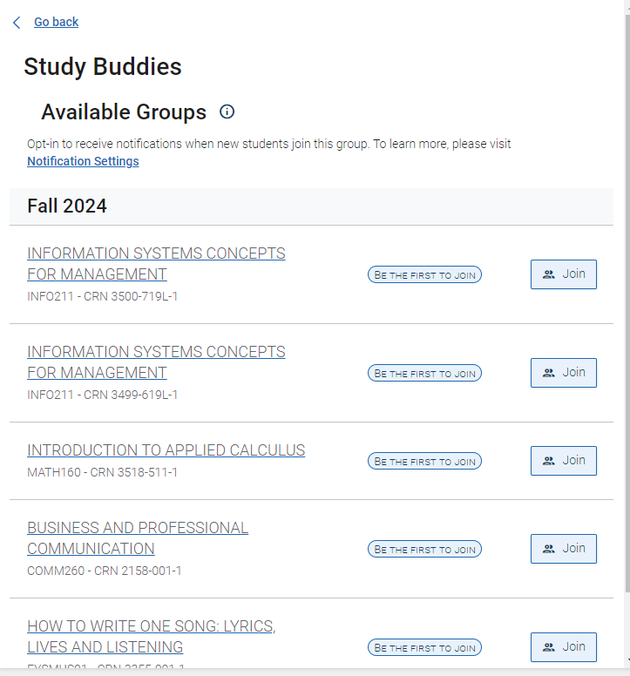

**Holds:** Students can see if they have a hold on their account. Students need to take care of holds to register for classes.

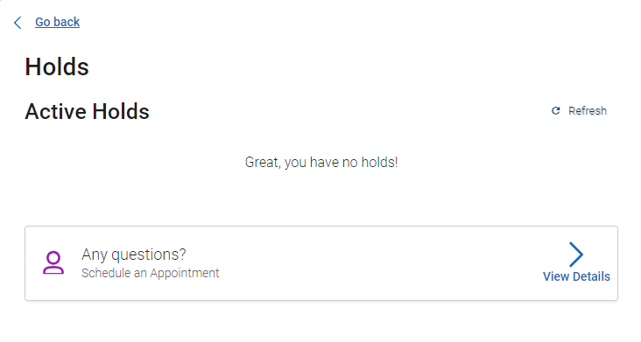

**Notifications:** Students can see events and to-do’s by clicking on this icon.

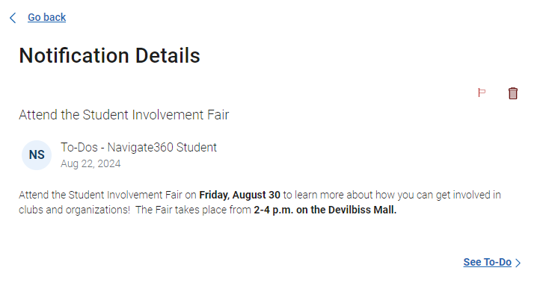

**Forage:** New! Career Resource

